



# IN THE NAME OF ALLAH THE MOST BENEFICENT AND MERCIFUL

**As Salamo Alaikum Wa Rahmatullahi Wa Barkatahu,**

I am thankful to Allah for giving me the opportunity to compile many of my favorite Moral Stories, in the form of an electronic book, which I had collected from various resources, since last few years. Even though many of these stories are fictional in

nature, but at the end they will give a great lesson to learn for a lifetime.

As the reader can himself see from these stories, the subject “Moral” is universal to every human being. Hence these stories are not just for any particular sect or the

followers of particular faith, it is for the entire humanity, irrespective of there belief, culture, race, color or age. So, let’s start with a Moral Story called as “**A POND FULL OF MILK**.”

Once there was a king who told some of his workers to dig a pond. Once the pond was dug, the king made an announcement to his people saying that one person from each household has to bring a glass of milk during the night and pour it into the pond. So, the pond should be full of milk by the morning. After receiving the order, everyone

went home.

One man prepared to take the milk during the night. He thought that since everyone

will bring milk, he could just hide a glass of water and pour inside the pond. Because it will be dark at night, no one will notice. So he quickly went and poured the water in the pond and came back. In the morning, the king came to visit the pond and to his

surprise the pond was only filled with water! What has happened is that everyone was thinking like the other man that “I don't have to put the milk, someone else will do it.”

Dear friends, when it comes to help the Religion of Allah, do not think that others will take care of it. Rather, it starts from you, if you don’t do it, no one else will do it. So, change yourself to the way of Allah to serve Him and that will make the difference.

With this I will end my little introduction and pray that May Almighty Allah accept it. So that we may all benefit from these stories.

Wassalamu Alaikum Wa Rahmutallahi Wa Barkatahu Akramulla Syed

**Islamic Occasions Network**

[http://www.islamicoccasions.com](http://www.islamicoccasions.com/)

Dated: Sunday, March 20, 2005

# LIST OF CONTENTS

1. A POND FULL OF MILK. 01
2. DON'T CHANGE THE WORLD. 03
3. THE TRAVELERS AND THE TREE. 03
4. LEARN FROM MISTAKES. 03
5. THE BOY WHO CRIED 'WOLF'. 04
6. THE FARMER AND THE STORK. 04
7. THE HARE AND THE TORTOISE. 05
8. THE ANT AND THE DOVE. 05
9. THE MONKEY AND THE DOLPHIN. 06
10. THE FOX AND THE STORK. 06
11. THE WOLF AND THE LAMB. 07
12. THE FOX AND THE GRAPES. 07
13. THE THIRSTY CROW. 08
14. THE MILKMAID. 08
15. PARABLE OF THE PENCIL. 09
16. THE BOY AND THE APPLE TREE. 10
17. THE ANGEL. 11
18. THE DEVOTED MOTHER. 12
19. MENTALLY RETARDED!. 12
20. PAID IN FULL. 13
21. BEAUTIFUL GIFT!. 14
22. WHAT IS A FAMILY?. 14
23. TRUE WEALTH. 16
24. A HOLE IN THE FENCE. 16
25. GRANDPA’S TABLE. 17
26. FATHERS EYES. 17
27. BUTTERFLY AND COCOON. 19
28. THE OBSTACLE IN OUR PATH. 19
29. THE WOLF IN SHEEP’S CLOTHING. 20
30. DON’T JUDGE A BOOK BY ITS COVER!. 20
31. MOUNTAIN STORY. 21
32. A LESSON FROM A FROG TALE. 22
33. WEAKNESS OR STRENGTH?. 22
34. JUST P.U.S.H!. 23
35. DETERMINATON. 24
36. THE CRACKED POT. 26
37. GOD EXISTS. 27
38. A BOY WITH STRONG BELIEF. 27
39. A VERY POWERFUL STORY. 28
40. WORDS & ACTIONS SHOULD BE SAME. 29
41. YOU'RE MORE PRECIOUS THAN PEARLS. 30
42. THE ONE-EYED DOE. 30
43. THE CAGE BIRD'S ESCAPE. 31
44. THE THREE WISE MEN. 32
45. THE CLEVER BOY. 33
46. A MERCHANT AND HIS DONKEY. 33
47. THE ANT AND THE GRASSHOPPER. 34
48. THE FOX WHO GOT CAUGHT IN TREE. 34
49. CATS AND ROOSTERS. 35
50. THE PROUD RED ROSE. 36
51. THE SELFISH MAN. 37
52. YOU ARE PRICELESS. 37
53. BE CAREFUL WHAT YOU PLANT. 38
54. GENEROSITY. 39
55. THE CRYSTAL BALL. 40
56. THE SIGNS OF HAPPINESS. 41
57. HOPE AND GREED. 42
58. FOUR WIVES. 43
59. LION, RATS, SNAKE & HONECOMB. 44
60. THE MOST BEAUTIFUL HEART. 45
61. THE CLUB 99. 46
62. REPENTANCE. 47
63. THE NEIGHBOR. 48
64. A BOX FULL OF KISSES. 48
65. THE THREE COWS. 49
66. A WHITE HAS NO SUPERIORITY. 50
67. GHULAMHUSSEIN AND THE GAME. 51
68. FINDERS KEEPERS. 51
69. BANDAGE OF COMPLAINT!. 51
70. AN AGED STUDENT. 52
71. WEALTH - LOVE - SUCCESS. 53
72. LOVE AND TIME. 54
73. ALWAYS THANKFUL TO GOD. 54
74. THE MAYONNAISE AND THE COFFEE. 55
75. THE BAR. 55
76. LESSONS ON LIFE. 56
77. THE ROSE WITHIN. 56
78. PUT THE GLASS DOWN!. 57
79. MAY I NEVER GET TOO BUSY. 58
80. DON’T WE ALL. 58
81. THE STRANGER IN THE GARDEN. 60
82. TO TELL THE TRUTH. 60
83. WHEN THE WINDS BLOW. 61
84. THE ROPE. 62
85. THE SHIP. 62
86. THE CLEVER KING!. 63
87. THE ILLUSION OF REFLECTION. 65
88. BUILDING YOUR HOUSE. 66
89. SAND AND STONE. 66
90. A TEACHER’S PROTEST!. 67
91. DO NOT DO EVIL TO ANYONE. 68
92. PUPPIES FOR SALE. 68
93. OFFFICE BOY. 69
94. ONE BEDROOM FLAT. 70
95. THEY ARE NOT IN NEED. 71
96. YOU ARE BEAUTIFUL!. 72
97. BE PATIENT. 73
98. THE FATHER AND HIS SONS. 73
99. A SENSE OF A GOOSE. 74

100. MAKING A DIFFERENCE. 74

**DON'T CHANGE THE WORLD**

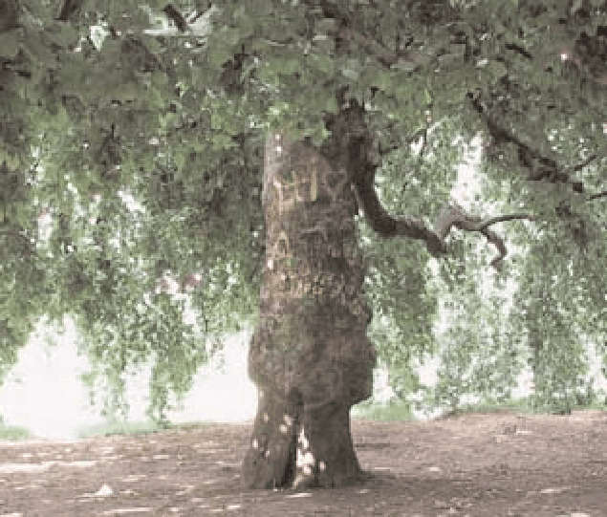

Once upon a time, there was a king who ruled a prosperous country. One day, he went for a trip to some distant areas of his country. When he was back to his palace, he complained that his feet were very painful, because it was the first time that he went for such a long trip, and the road that he went through was very rough and stony. He then ordered his people to cover every road of the entire country with leather.

Definitely, this would need thousands of cows’ skin, and would cost a huge amount of money.

Then one of his wise servants dared himself to tell the king, “Why do you have to spend that unnecessary amount of money? Why don’t you just cut a little piece of leather to cover your feet?”

The king was surprised, but he later agreed to his suggestion, to make a “shoe” for himself.

**There is actually a valuable lesson of life in this story: to make this world a happy place to live, you better change yourself - your heart; and not the world.**

# THE TRAVELERS AND THE PLANE TREE

Two men were walking along one summer day. Soon it became too hot to go any further and, seeing a large plane tree nearby, they threw themselves on the ground to rest in its shade.

Gazing up into the branches one man said to the other:

“What a useless tree this is. It does not have fruit or nuts that we can eat and we cannot even use its wood for anything.”

“Don’t be so ungrateful,” rustled the tree in reply. “I am being extremely useful to you at this very moment, shielding you from the hot sun.

And you call me a good-for-nothing!”

**All of God’s creations have a good purpose.**

**Islam teaches us that we should never belittle Allah’s blessings.**

# LEARN FROM MISTAKES

Thomas Edison tried two thousand different materials in search of a filament for the light bulb. When none worked satisfactorily, his assistant complained,

“All our work is in vain. We have learned nothing.”

Edison replied very confidently, “Oh, we have come a long way and we have learned a lot. We now know that there are two thousand elements which we cannot use to make a good light bulb.”

# THE BOY WHO CRIED 'WOLF'

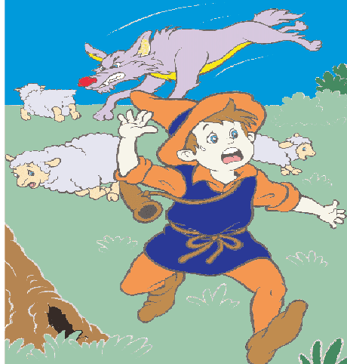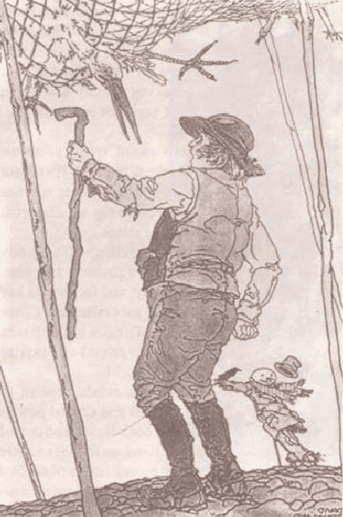

Once there was a shepherd boy who had to look after a flock of sheep. One day, he felt bored and decided to play a trick on the villagers. He shouted, “Help! Wolf! Wolf!”

The villagers heard his cries and rushed out of the village to help the shepherd boy. When they reached him, they asked,

“Where is the wolf?”

The shepherd boy laughed loudly, “Ha, Ha, Ha! I fooled all of you. I was only playing a trick on you.”

A few days later, the shepherd boy played this trick again.

Again he cried, “Help! Help! Wolf! Wolf!” Again, the villagers rushed up the hill to help him and again they found that boy had tricked them. They were very angry with him for being so naughty.

Then, some time later, a wolf went into the field. The wolf attacked one sheep, and then another and another. The shepherd boy ran towards the village shouting, “Help! Help! Wolf! Help!

Somebody!”

The villagers heard his cries but they laughed because they thought it was another trick. The boy ran to the nearest villager and said, “A wolf is attacking the sheep. I lied before, but this time it is true!”

Finally, the villagers went to look. It was true. They could see the wolf running away and many dead sheep lying on the grass.

**We may not believe someone who often tells lies, even when he tells the truth.**

# THE FARMER AND THE STORK

Finding that cranes were destroying his newly sown corn, a farmer one evening set a net in his field to catch the destructive birds.

When he went to examine the net next morning he found a number of cranes and also a stork.

“Release me, I beseech you,” cried the stork, “for I have eaten none of your corn, nor have I done you any harm. I am a poor innocent stork, as you may see - a most dutiful bird, I honor my father and mother.

I...”

But the farmer cut him short. “All this may be true enough, I dare say, but I have caught you with those were destroying my crops, and you must suffer with the company in which you are found.”

**People are judged by the company they keep.**

# THE HARE AND THE TORTOISE

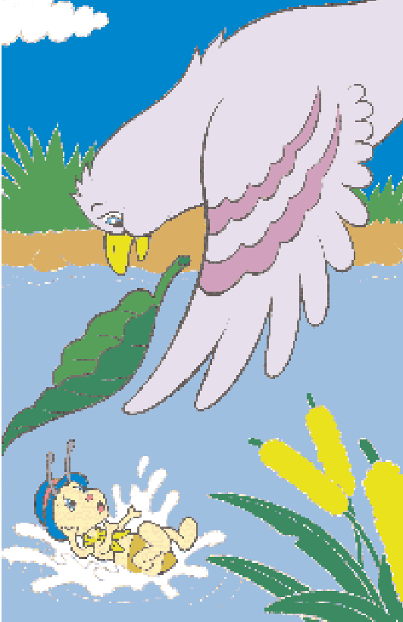

A tortoise one day met a hare who made fun of her. “My, my, you move so slowly, you will never get far!”

The tortoises, upset by the hare’s manner, said, “Let’s have a race and see who is faster.”

The hare laughed and said, “You must be joking! But all right, we’ll see who reaches the other side of the hill first.” Off he ran, leaving the tortoise far behind.

After a while, the hare stopped to wait for the tortoise to come long. He waited and waited till he felt sleepy. “I might as well take a nap,” he thought. “Even if she catches up with me, I can easily win the race.” So he lay down under a shady tree and closed his eyes.

When the tortoise passed the sleeping hare, she walked on slowly but steadily. By the time the hare woke up, the tortoise was near the finishing line. He ran as fast as he could, but he could not catch up with the tortoise.

**Slow and steady can win the race.**

# THE ANT AND THE DOVE

One hot day, an ant was searching for some water.

After walking around for some time, she came to a spring.

To reach the spring, she had to climb up a blade of grass. While making her way up, she slipped and fell into the water.

She could have drowned if a dove up a nearby tree had not seen her. Seeing that the ant was in trouble, the dove quickly plucked off a leaf and dropped it into the water near the struggling ant. The ant moved towards the leaf and

climbed up there. Soon it carried her safely to dry ground.

Just at that time, a hunter nearby was throwing out his net towards the dove, hoping to trap it.

Guessing what he was about to do, the ant quickly bit him on the heel. Feeling the pain, the hunter dropped his net. The dove was quick to fly away to safety.

**One good turn deserves another.**

# THE MONKEY AND THE DOLPHIN

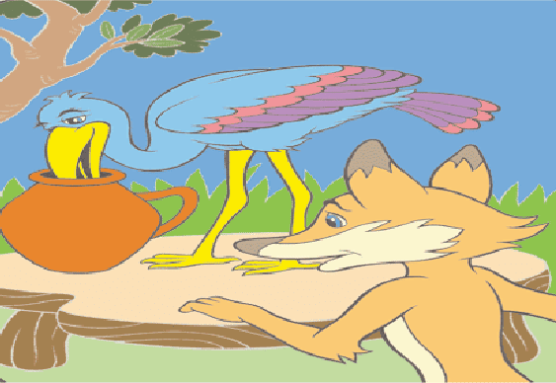

One day long ago, some sailors set out to sea in their sailing ship. One of them brought his pet monkey along for the long journey.

When they were far out at sea, a terrible storm overturned their ship. Everyone fell into the sea, and the monkey was sure that he would drown. Suddenly a dolphin appeared and picked him up.

They soon reached the island and the monkey came down from the dolphin’s back. The dolphin asked the monkey, “Do you know this place?”

The monkey replied, “Yes, I do. In fact, the king of the island is my best friend. Do you know that I am actually a prince?”

Knowing that no one lived on the island, the dolphin said, “Well, well, so you are a prince! Now you can be a king!”

The monkey asked, “How can I be a king?”

As the dolphin started swimming away, he answered, “That is easy. As you are the only creature on this island, you will naturally be the king!”

**Those who lie and boast may end up in trouble.**

# THE FOX AND THE STORK

A selfish fox once invited a stork to dinner at his home in a hollow tree. That evening, the stork flew to the fox’s home and knocked on the door with her long beak. The fox opened the door and said, “Please come in and share my food.”

The stork was invited to sit down at the table. She was very hungry and the food smelled delicious! The fox served soup in shallow bowls and he licked up all his soup very quickly. However, the stork could not have any of it as the bowl was too shallow for her long beak. The poor stork just smiled politely and stayed hungry.

The selfish fox asked, “Stork, why haven’t you taken your soup? Don’t you like it?” The stork replied, “It was very kind of you to invite me for dinner.

Tomorrow evening, please join me for dinner at my home.”

The next day, when the fox arrived at the stork’s home, he saw that they were also having soup for dinner. This time the soup was served in tall jugs. The stork drank the soup easily but the fox could not reach inside the tall jug. This time it was his turn to go hungry.

**A selfish act can backfire on you.**

# THE WOLF AND THE LAMB

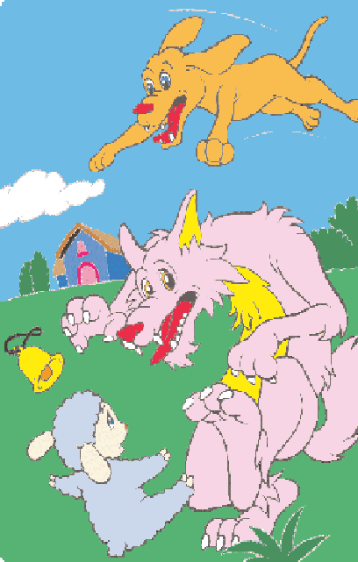

A lamb was grazing with a flock of sheep one day. She soon found some sweet grass at the edge of the field. Farther and farther she went, away from the others.

She was enjoying herself so much that she did not notice a wolf coming nearer to her. However, when it pounced on her, she was quick to start pleading, “Please, please don’t eat me yet. My stomach is full of grass. If you wait a while, I will taste much better.”

The wolf thought that was a good idea, so he sat down and waited. After a while, the lamb said, “If you allow me to dance, the grass in my stomach will be digested faster.” Again the wolf agreed.

While the lamb was dancing, she had a new idea. She said,

“Please take the bell from around my neck. If you ring it as hard as you can, I will be able to dance even faster.”

The wolf took the bell and rang it as hard as he could. The shepherd heard the bell ringing and quickly sent his dogs to find the missing lamb. The barking dogs frightened the wolf away and saved the lamb’s life.

**The gentle and weak can sometimes be cleverer than fierce and strong.**

# THE FOX AND THE GRAPES

It was a sunny day and fox was walking across the fields. Soon he came to a vineyard. As he came nearer, he could see some bunches of juicy grapes.

The fox looked carefully around him. He had to make sure that he was safe from the hunters. He decided to steal some before anyone came along.

He jumped upwards but he could not reach the grapes. He jumped again as high as he could. He still could not reach them. The grapes were just too high for him!

He was not ready to give up. He backed off, took some running steps and leapt into the air towards the grapes. Again he failed to reach them.

It was getting dark, and he was getting angry. His legs hurt with all that running and jumping. At last he stopped trying.

As he walked away, he said to himself, “I don’t really want those grapes. I’m sure they are too sour to eat.”

**Sometimes when we cannot get what we want, we pretend that it is not worth having.**

# THE THIRSTY CROW

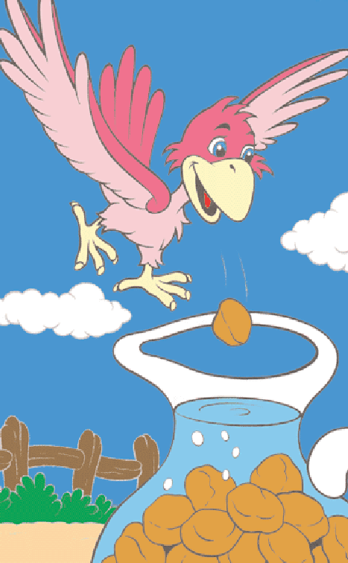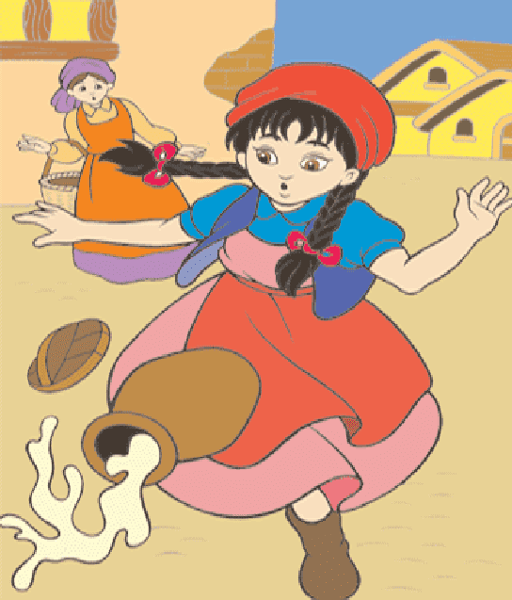

One hot day, a thirsty crow flew all over the fields looking for water. For a long time, she could not find any. She felt very weak, almost giving up hope.

Suddenly, she saw a water jug below her. She flew straight down to see if there was any water inside. Yes, she could see some water inside the jug!

The crow tried to push her head into the jug. Sadly, she found that the neck of the jug was too narrow. Then she tried to push the jug down for the water to flow out. She found that the jug was too heavy.

The crow thought hard for a while. Then looking around her, she saw some pebbles. She suddenly had a good idea. She started picking up the pebbles one by one, dropping each into the jug.

As more and more pebbles filled the jug, the water level kept rising. Soon it was high enough for the crow to drink. Her plan had worked!

**If you try hard enough, you may soon find an answer to your problem.**

# THE MILKMAID

A milkmaid was on her way to the market to sell some milk from her cow. As she carried the large jug of milk on top of her head, she began to dream of all the things she could do after selling the milk.

“With that money, I’ll buy a hundred chicks to rear in my backyard. When they are fully grown. I can sell them at a good price at the market.”

As she walked on, she continued dreaming, “Then I’ll buy two young goats and rear them on the grass close by. When they are fully grown, I can sell them at an even better price!”

Still dreaming, she said to herself, “Soon, I’ll be able to buy another cow, and I will have more milk to sell. Then I shall have even more money...”

With these happy thoughts, she began to skip and jump. Suddenly she tripped and fell. The jug broke and all the milk spilt onto the ground.

No more dreaming now, she sat down and cried.

**Do not count your chickens before they are hatched.**

# PARABLE OF THE PENCIL



The Pencil Maker took the pencil aside, just before putting him into the box.

“There are 5 things you need to know,” he told the pencil, “Before I send you out into the world. Always remember them and never forget, and you will become the best pencil you can be.”

One: “You will be able to do many great things, but only if you allow yourself to be held in someone’s hand.”

Two: “You will experience a painful sharpening from time to time, but you’ll need it to become a better pencil.”

Three: “You will be able to correct any mistakes you might make.”

Four: “The most important part of you will always be what's inside.”

And Five: “On every surface you are used on, you must leave your mark. No matter what the condition, you must continue to write.”

The pencil understood and promised to remember, and went into the box with purpose in its heart.

Now replacing the place of the pencil with you. Always remember them and never forget, and you will become the best person you can be.

One: “You will be able to do many great things, but only if you allow yourself to be held in God’s hand. And allow other human beings to access you for the many gifts you possess.”

Two: “You will experience a painful sharpening from time to time, by going through various problems in life, but you’ll need it to become a stronger person.”

Three: “You will be able to correct any mistakes you might make.”

Four: “The most important part of you will always be what’s on the inside.”

And Five: “On every surface you walk through, you must leave your mark. No matter what the situation, you must continue to do your duties.”

Allow this parable on the pencil to encourage you to know that you are a special person and only you can fulfill the purpose to which you were born to accomplish.

**Never allow yourself to get discouraged and think that your life is insignificant and cannot make a change.**

# THE BOY AND THE APPLE TREE

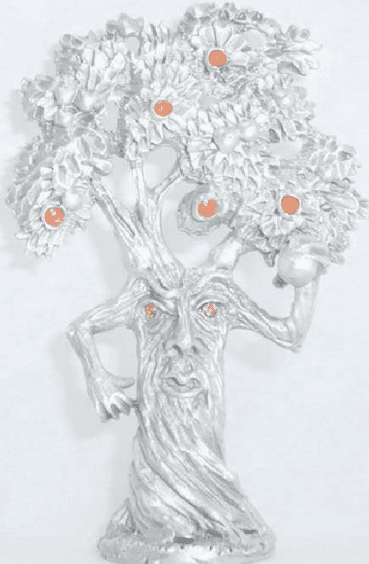

A long time ago, there was a huge apple tree. A little boy loved to come and play around it everyday. He climbed to the treetop, ate the apples, and took a nap under the shadow. He loved the tree and the tree loved to play with him. Time went by, the little boy had grown up and he no longer played around the tree every day.

One day, the boy came back to the tree and he looked sad. “Come and play with me”, the tree asked the boy.

“I am no longer a kid, I do not play around trees any more” the boy replied.

“I want toys. I need money to buy them.”

“Sorry, but I do not have money, but you can pick all my apples and sell them. So, you will have money.”

The boy was so excited. He grabbed all the apples on the tree and left happily. The boy never came back after he picked the apples. The tree was sad.

One day, the boy who now turned into a man returned and the tree was excited.

“Come and play with me” the tree said.

“I do not have time to play. I have to work for my family. We need a house for shelter. Can you help me?”

“Sorry, but I do not have any house. But you can chop off my branches to build your house.” So the man cut all the branches of the tree and left happily. The tree was glad to see him happy but the man never came back since then. The tree was again lonely and sad.

One hot summer day, the man returned and the tree was delighted. “Come and play with me!” the tree said.

“I am getting old. I want to go sailing to relax myself. Can you give me a boat?” said the man. “Use my trunk to build your boat. You can sail far away and be happy.”

So the man cut the tree trunk to make a boat. He went sailing and never showed up for a long time.

Finally, the man returned after many years. “Sorry, my boy. But I do not have anything for you anymore. No more apples for you”, the tree said. “No problem, I do not have any teeth to bite” the man replied.

“No more trunk for you to climb on.” “I am too old for that now” the man said.



“I really cannot give you anything, the only thing left is my dying roots,” the tree said with tears.

“I do not need much now, just a place to rest. I am tired after all these years,” the man replied.

“Good! Old tree roots are the best place to lean on and rest, come sit down with me and rest.” The man sat down and the tree was glad and smiled with tears.

This is a story of everyone. The tree is like our parents. When we were young, we loved to play with our Mum and Dad. When we grow up, we leave them; only come to them when we need something or when we are in trouble. No matter what, parents will always be there and give everything they could just to make you happy.

You may think the boy is cruel to the tree, but that is how all of us treat our parents. We take them for granted; we don’t appreciate all they do for us, until it’s too late. Wallahi, May Allah forgives us of our shortcomings and may He guide us.

# THE ANGEL

Once upon a time there was a child ready to be born. One day the child asked God, “They tell me you are going to send me to earth tomorrow but how am I going to live there being so small and helpless?” God replied, “Among the many angels I have chosen one for you. She will be waiting for you and will take care of you.”

Said child, “But tell me here in Heaven I don’t do anything else but sing and smile. That’s what I need to be happy!” God replied, “Your angel will sing for you every day. And you will feel your angel’s love and be happy.”

And, said the child, “How am I going to be able to understand when people talk to me, if I don’t know the language that men talk?” “That’s easy”, God said, “Your angel will tell you the most beautiful and sweet words you will ever hear, and with much patience and care, your angel will teach you how to speak.” The child looked up at God saying, “And what am I going to do when I want to talk to you?” God smiled at the child saying, “Your angel will teach you how to pray.”

The child said, “I’ve heard on earth there are bad men. Who will protect me?” God replied, “Your angel will defend you, even if it means risking life!” The child looked sad, saying, “But I will always be sad because I will not see you anymore.” God replied, “Your angel will always talk to you about me and will teach you the way to come back to

me, even though I will always be next to you.”

At that moment there was much peace in Heaven, but voices from earth could already be heard.

The child in a hurry, asked softly, “Oh God, if

I am about to leave now please tell me my angel’s name!” God replied, Your angel’s name is of no importance… you will simply call her

**MOTHER!**

# THE DEVOTED MOTHER



A mother duck and her little ducklings were on their way to the lake one day. The ducklings were very happy following their mother and quack-quacking along the way.

All of a sudden the mother duck saw a fox in the distance. She was frightened and shouted, “Children, hurry to the lake. There’s a fox!”

The ducklings hurried towards the lake. The mother duck

wondered what to do. She began to walk back and forth dragging one wing on the ground.

When the fox saw her he became happy. He said to himself, “It seems that she’s hurt and can’t fly! I can easily catch and eat her!” Then he ran towards her.

The mother duck ran, leading the fox away from the lake. The fox followed her. Now he wouldn’t be able to harm her ducklings. The mother duck

looked towards her ducklings and saw that they had reached the lake. She was relieved, so she stopped and took a deep breath.

The fox thought she was tired and he came closer, but the mother duck quickly spread her wings and rose up in the air. She landed in the middle of the lake and her ducklings swam to her.

The fox stared in disbelief at the mother duck and her ducklings. He could not reach them because they were in the middle of the lake.

**Dear children, some birds drag one of their wings on the ground when an enemy is going to attack. In this way they fool their enemies into thinking they are hurt. When**

**the enemy follows them this gives their children time to escape.**

# MENTALLY RETARDED!

A few years ago, at the Seattle Special Olympics, nine contestants, all physically or mentally disabled, assembled at the starting line for the 100-yard dash.

At the gun, they all started out, not exactly in a dash, but with a relish to run the race to the finish and win. All, that is, except one little boy who stumbled on the

asphalt, tumbled over a couple of times, and began to cry. The other eight heard the boy cry. They slowed down and looked back. Then they all turned around and went back. every one of them.

One girl with Down’s syndrome bent down and kissed him and said, “This will make it better.” Then all nine linked arms and walked together to the finish line. Everyone in the stadium stood, and the cheering went on for several minutes. People who were there are still telling the story.

**Why? Because deep down we know this one thing: What matters in this life is more than winning for ourselves. What matters in this life is helping others win, even if it means slowing down and changing our course.**

# PAID IN FULL

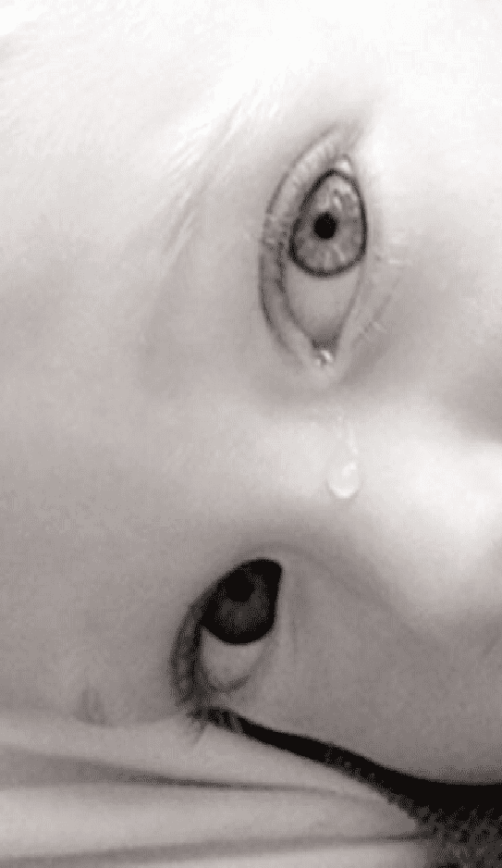

A little boy came up to his mother in the kitchen one evening while she was fixing supper, and he handed her a piece of paper that he had been writing on. After his mom dried her hands on an apron, she read it, and this is what it said:

For cutting the grass: $5.00

For cleaning up my room this week: $1.00 For going to the store for you: $.50

Baby-sitting my kid brother while you went shopping: $.25 Taking out the garbage: $1.00

For getting a good report card: $5.00

For cleaning up and raking the yard: $2.00 Total owed: $14.75

Well, his mother looked at him standing there, and the boy could see the memories flashing through her mind. She picked up the pen, turned over the paper he had written on, and this is what she wrote:

For the nine months I carried you while you were growing inside me: No Charge.

For all the nights that I’ve sat up with you, doctored and prayed for you: No Charge.

For all the trying times, and all the tears that you’ve caused through the years: No Charge.

For all the nights filled with dread, and for the worries I knew were ahead: No Charge.

For the toys, food, clothes, and even wiping your nose: No Charge.

When you add it up, the cost of my love is: No Charge.

When the boy finished reading what his mother had written, there were big tears in his eyes, and he looked

straight up at his mother and said, “Mom, I sure do love you.”

And then he took the pen and in great big letters he wrote:

**“PAID IN FULL.”**

# BEAUTIFUL GIFT!



A young man was getting ready to graduate college. For many months he had admired a beautiful sports car in a dealer’s showroom, and knowing his father could well afford it, he told him that was all he wanted. As Graduation Day approached, the young man awaited signs that his father had purchased the car. On the morning of his graduation his father called him into his private study.

His father told him how proud he was to have such a fine son, and told him how much he loved him. He handed his son a beautiful wrapped gift box. Curious, but somewhat disappointed the young man opened the box and found a lovely, leather-bound Holy Qur’an. Angrily, he raised his voice at his father and said, “With all your money you give me a Holy book?” and stormed out of the house, leaving the holy book.

He never contacted his father again for long long time. Many years passed and the young man was very successful in business. He had a

beautiful home and wonderful family, but realized his father was very old, and thought perhaps he should go to him. He had not seen him since that graduation day.

Before he could make arrangements, he received a telegram telling him his father had passed away, and willed all of his possessions to his son. He needed to come home immediately and take care things. When he arrived at his father’s house, sudden sadness and regret filled his heart. He began to search his father’s important papers and saw the still new Holy Qur’an, just as he had left it years ago. With tears, he opened the Holy Qur’an and began to turn the pages. As he Read those words, a car key dropped from an envelope taped behind the Holy Qur’an. It had a tag with the dealer’s name, the same dealer who had the sports car he had desired. On the tag was the date of his graduation, and the words PAID IN FULL.

**How many times do we miss GOD blessings because they are not packaged as we expected?**

# WHAT IS A FAMILY?

A man came home from work late, tired and irritated, to find his 5-year old son waiting for him at the door.

SON: “Daddy, may I ask you a question?” DAD: “Yeah sure, what is it?” replied the man.

SON: “Daddy, how much do you make an hour?”

DAD: “That’s none of your business. Why do you ask such a thing?” the man said angrily. SON: “I just want to know. Please tell me, how much do you make an hour?”

DAD: “If you must know, I make $20 an hour.”

“Oh,” the little boy replied, with his head down. Looking up, he said, “Daddy, may I please borrow $10?”

The father was furious, “If the only reason you asked that is so you can borrow some money to buy a silly toy or some other nonsense, then you march yourself straight to your room and go to bed.

Think about why you are being so selfish. I work hard everyday for such this childish behavior.”

The little boy quietly went to his room and shut the door. The man sat down and started to get even angrier about the little boy’s questions. How dare he ask such questions only to get some money?

After about an hour or so, the man had calmed down, and started to think: Maybe there was something he really needed to buy with that $10 and he really didn’t ask for money very often.

The man went to the door of the little boy’s room and opened the door. “Are you asleep, son?” He asked. “No daddy, I’m awake,” replied the boy.

“I’ve been thinking, maybe I was too hard on you earlier,” said the man. “It’s been a long day and I took out my aggravation on you. Here’s the $10 you asked for.”

The little boy sat straight up, smiling. “Oh, thank you daddy!” He yelled. Then, reaching under his pillow he pulled out some crumpled up bills.

The man, seeing that the boy already had money, started to get angry again. The little boy slowly counted out his money, and then looked up at his father. “Why do you want more money if you already have some?” the father grumbled. “Because I didn’t have enough, but now I do,” the little boy replied.

“Daddy, I have $20 now. Can I buy an hour of your time? Please come home early tomorrow. I would like to have dinner with you.”

Share this story with someone you like. But even better, share $20 worth of time with someone

you love. It’s just a short reminder to all of you working so hard in life.

We should not let time slip through our fingers without having spent some time with those who really matter to us, those close to our hearts.

If we die tomorrow, the company that we are working for could easily replace us in a matter of days.

But the family & friends we leave behind will feel the loss for the rest of their lives. And come to think of it, we pour ourselves more into work than to our family. An unwise investment indeed!

So what is the moral of the story???

Don’t work too hard. and you know what’s the full word of FAMILY?

**FAMILY = (F)ATHER (A)ND (M)OTHER,(I)(L)OVE (Y)OU!**

# TRUE WEALTH

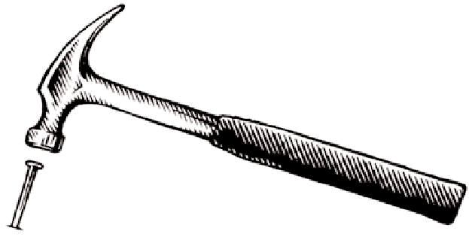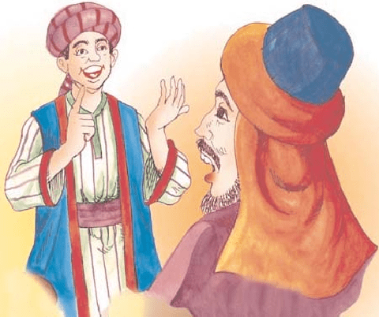

One day a father of a very wealthy family took his son on a trip to the country with the purpose of showing his son how the poor people live so he could be thankful for his wealth.

They spent a couple of days and nights on the farm of what would be considered a very poor family.

On their return from their trip, the father asked his son, “How was the trip?” “It was great, Dad.” “Did you see how poor people can be?” the father asked. “Oh yeah” said the son. “So what did you learn from the trip?” asked the father.

The son answered, “I saw that we have one dog and they had four. We have a pool that reaches to the middle of our garden and they have a creek that has no end.” “We have imported lanterns in our garden and they have the stars at night.” “Our patio reaches to the front yard and they have the whole horizon.” “We have a small piece of land to live on and they have fields that go beyond our sight.” “We have servants who serve us, but they serve others.” “We buy our food, but they grow theirs.” “We have walls around our property to protect us; they have friends to protect them.”

With this the boy’s father was speechless. Then his son added, “Thanks dad for showing me how poor we are.”

# A HOLE IN THE FENCE

There once was a little boy who had a bad temper. His Father gave him a bag of nails and told him that every time he lost his temper, he must hammer a nail into the back of the fence.

The first day the boy had driven 37 nails into the fence. Over the next few weeks, as he learned to control his anger, the number of nails hammered daily gradually dwindled down. He discovered it was easier to hold his temper than to drive those nails into the fence....

Finally the day came when the boy didn’t lose his temper at all. He told his father about it and the father suggested that the boy now pull out one nail for each day that he was able to hold his temper. The day passed and the young boy was finally able to tell his father that all the nails were gone. The father took his son by the hand and led him to the fence. He said, “You have done well, my son, but look at the holes in the fence.”

The fence will never be the same. When you say things in anger, they leave a scar just like this one. You can put a knife in a man and draw it out. It won’t matter how many times you say I’m sorry, the wound is still there. **A verbal wound is as bad as a physical one.**

Friends and loved ones are a very rare jewel, indeed. They make you smile and encourage you to succeed. They lend an ear, they share a word of praise, and they always want to open their hearts to us. Water your relationships with kindness… and they will grow. So be careful little lips what you say…! And you won't chase friendships away.

# GRANDPA’S TABLE

A frail old man went to live with his son, daughter-in-law, and four-year old grandson. The old man’s hands trembled, his eyesight was blurred, and his step faltered. The family ate together at the table. But the elderly grandfather’s shaky hands and failing sight made eating difficult. Peas rolled off his spoon onto the floor. When he grasped, the glass, milk spilled on the tablecloth.

The son and daughter-in-law became irritated with the mess. “We must do something about Grandfather,” said the son. “I’ve had enough of his spilled milk, noisy eating, and food on the floor.” So the husband and wife set a small table in the corner. There, Grandfather ate alone while the rest of the family enjoyed dinner. Since Grandfather had broken a dish or two, his food was served in a wooden bowl. When the family glanced in Grandfather’s direction, sometimes he had a tear in his eye as he sat alone. Still, the only words the couple had for him were sharp admonitions when he dropped a fork or spilled food. The four-year-old watched it all in silence.

One evening before supper, the father noticed his son playing with wood scraps on the floor. He asked the child sweetly, “What are you making?” Just as sweetly, the boy responded, “Oh, I am making a little bowl for you and Mama to eat your food in when I grow up.” The four-year-old smiled and went back to work. The words so struck the parents that they were speechless. Then tears started to stream down their cheeks. Though no word was spoken, both knew what must be done.

That evening the husband took Grandfather’s hand and gently led him back to the family table. For the remainder of his days he ate every meal with the family.

And for some reason, neither husband nor wife seemed to care any longer when a fork was dropped, milk spilled, or the tablecloth soiled.

**“Little Things Affect Little Minds”**

**BENJAMIN DISRAELI**

Children are remarkably perceptive. Their eyes ever observe, their ears ever listen, and their minds ever process the messages they absorb. If they see us patiently provide a happy home atmosphere for family members, they will imitate that attitude for the rest of their lives. The wise parent realizes that every day the building blocks are being laid for the child’s future. Let’s be wise builders and role models.

**“Life is about people connecting with people, and making a positive difference.**

**Take care of yourself, ... and those you love, ... today, ... and everyday!”**

# FATHERS EYES

A teenager lived alone with his father, and the two of them had a very special relationship. The father believed in encouragement. Even though the son was always on the bench, his father was always in the stands cheering. He never missed a game.

This young man was the smallest of the class when he entered high school. His father continued to encourage him but also made it very clear that he did not have to play football if he didn’t want to.

But the young man loved football and decided to hang in there. He was determined to try his best at every practice, and perhaps he’d get to play when he became a senior. All through high school he never missed a practice or a game, but remained a bench warmer all four years. His faithful father was always in the stands, always with words of encouragement for him. When the young man went

to college, he decided to try out for the football team as a “walk-on.”

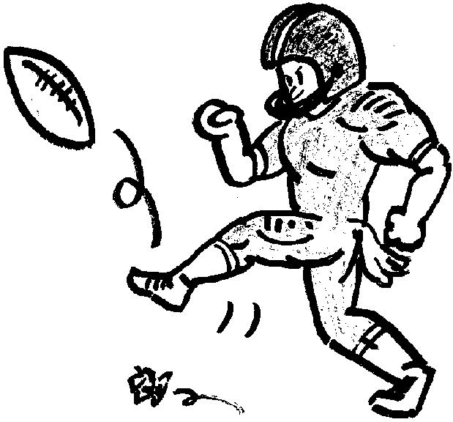

Everyone was sure he could never make the cut, but he did. The coach admitted that he kept him on the roster because he always puts his heart and soul to every practice, and at the same time, provided the other members with the spirit and hustle they badly needed. The news that he had survived the cut thrilled him so much that he rushed to the nearest phone and called his father.

His father shared his excitement and was sent season tickets for all the college games. This persistent young athlete never missed practice during his four years at college, but he never got to play in the game.

It was the end of his senior football season, and as he trotted onto the practice field shortly before the big play off game, the coach met him with a telegram. The young man read the telegram and he became deathly silent. Swallowing hard, he mumbled to the coach, “My father died this morning.

Is it all right if I miss practice today?”

The coach put his arm gently around his shoulder and said, “Take the rest of the week off, son. And don’t even plan to come back to the game on Saturday.” Saturday arrived, and the game was not going well.

In the third quarter, when the team was ten points behind, a silent young man quietly slipped into the empty locker room and put on his football gear. As he ran onto the sidelines, the coach and his players were astounded to see their faithful team-mate back so soon.

“Coach, please let me play. I’ve just got to play today,” said the young man.

The coach pretended not to hear him. There was no way he wanted his worst player in this close playoff game. But the young man persisted, and finally feeling sorry for the kid, the coach gave in. “All right,” he said. “You can go in.” Before long, the coach, the players and everyone in the stands could not believe their eyes. This little unknown, who had never played before, was doing everything right. The opposing team could not stop him. He ran, he passed, blocked and tackled like a star. His team began to triumph.

The score was soon tied. In the closing seconds of the game, this kid intercepted a pass and ran all the way for the winning touchdown. The fans broke loose. His team-mates hoisted him onto their shoulders. Such cheering you’ve never heard!

Finally, after the stands had emptied and the team had showered and left the locker room, the coach noticed that the young man was sitting quietly in the corner all alone. The coach came to him and said, “Kid, I can’t believe it. You were fantastic!”

Tell me what got into you? How did you do it? He looked at the coach, with tears in his eyes, and said, “Well, you knew my dad died, but did you know that my dad was blind?” The young man swallowed hard and forced a smile, “Dad came to all my games, but today was the first time he could see me play, and I wanted to show him I could do it!”

# BUTTERFLY AND COCOON

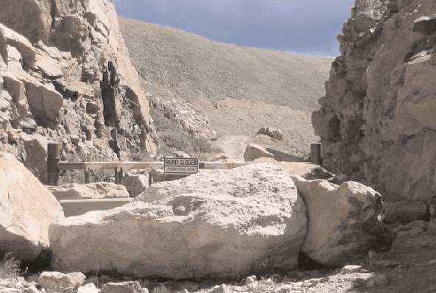

A man found a cocoon of a butterfly. One day a small opening appeared; he sat and watched the butterfly for several hours as it struggled to force its body through that little hole. Then it seemed to stop making any progress. It appeared as if it had gotten as far as it could and it could go no farther.

Then the man decided to help the butterfly, so he took a pair of scissors and snipped off the remaining bit of the cocoon. The butterfly then emerged easily. But it had a swollen body and small, shriveled wings.

The man continued to watch the butterfly because he expected that, at any moment, the wings would enlarge and expand to be able to support the body, which would contract in time.

Neither happened! In fact, the butterfly spent the rest of its life crawling around with a swollen body and shriveled wings. It never was able to fly.

What this man in his kindness and haste did not understand was that the restricting cocoon and the struggle required for the butterfly to get through the tiny opening were nature's way of forcing fluid from the body of the butterfly into its wings so that it would be ready for flight once it achieved its freedom from the cocoon.

**Sometimes struggles are exactly what we need in our life. If nature allowed us to go through our life without any obstacles, it would cripple us. We would not be as strong as what we could have been. And we could never fly...**

# THE OBSTACLE IN OUR PATH

In ancient times, a king had a boulder placed on a roadway. Then he hid himself and watched to see if anyone would remove the huge rock. Some of the king’s wealthiest merchants and courtiers came by and simply walked around it.

Many loudly blamed the king for not keeping the roads clear, but none did anything about getting the big stone out of the way. Then a peasant came along carrying a load of vegetables. On approaching the boulder, the peasant laid down his burden and tried to move the stone to the side of the road. After much pushing and straining, he finally succeeded. As the peasant picked up his load of vegetables, he noticed a purse lying in the road where the boulder had been.

The purse contained many gold coins and a note from the king indicating that the gold was for the person who removed the boulder from the roadway. The peasant learned what many others never understand.

**Every obstacle presents an opportunity to improve one’s condition.**

# THE WOLF IN SHEEP’S CLOTHING



A Wolf found great difficulty in getting at the sheep owing to the vigilance of the shepherd and his dogs. But one day it found the skin of a sheep that had been flayed and thrown aside, so it put it on over its own pelt and strolled down among the sheep. The Lamb that belonged to the sheep, whose skin the Wolf was wearing, began to follow the Wolf in the Sheep’s clothing; so, leading the Lamb a little apart, he soon made a meal off her, and for some time he succeeded in deceiving the sheep, and enjoying hearty meals.

**Appearances are deceptive.**

# DON’T JUDGE A BOOK BY ITS COVER!

A lady in a faded gingham dress and her husband, dressed in a homespun threadbare suit, stepped off the train in Boston and walk timidly without an appointment into the Harvard University President’s outer office.

The secretary could tell in a moment that such backwoods, country hicks had no business at Harvard and probably didn’t even deserve to be in Cambridge.

“We want to see the president,” the man said softly. “He’ll be busy all day,” the secretary snapped. “We’ll wait,” the lady replied.

For hours the secretary ignored them, hoping that the couple would finally become discouraged and go away. They didn’t and the secretary grew frustrated and finally decided to disturb the president, even though it was a chore she always regretted.

“Maybe if you see them for a few minutes, they’ll leave,” she said to him.

He sighed in exasperation and nodded. Someone of his importance obviously didn’t have the time to spend with them, but he detested gingham dresses and homespun suits cluttering up his outer office.

The president, stern faced and with dignity, strutted toward the couple.

The lady told him, “We had a son who attended Harvard for one year. He loved Harvard. He was happy here. But about a year ago, he was accidentally killed. My husband and I would like to erect a memorial to him, somewhere on campus.”

The president wasn’t touched. He was shocked.

“Madam,” he said, gruffly, “we can’t put up a statue for every person who attended Harvard and died. If we did, this place would look like a cemetery.”

“Oh, no,” the lady explained quickly. “We don’t want to erect a statue. We thought we would like to give a building to Harvard.”

The president rolled his eyes. He glanced at the gingham dress and homespun suit, and then exclaimed, “A building! Do you have any earthly idea how much a building costs? We have over seven and a half million dollars in the physical buildings here at Harvard.”



For a moment the lady was silent.

The president was pleased. Maybe he could get rid of them now.

The lady turned to her husband and said quietly, “Is that all it costs to start a university? Why don’t we just start our own?” Her husband nodded.

The president’s face wilted in confusion and bewilderment. Mr. and Mrs. Leland Stanford got up and walked away, traveling to Palo Alto, California where they established the University that bears their name, Stanford University, a memorial to a son that Harvard no longer cared about.

**You can easily judge the character of others by how they treat those who they think can do nothing.**

# MOUNTAIN STORY

A son and his father were walking on the mountains.

Suddenly, his son falls, hurts himself and screams: “AAAhhhhhhhhhhh!”

To his surprise, he hears the voice repeating, somewhere in the mountain: “AAAhhhhhhhhhhh!” Curious, he yells: “Who are you?”

He receives the answer: “Who are you?”

And then he screams to the mountain: “I admire you!” The voice answers: “I admire you!”

Angered at the response, he screams: “Coward!” He receives the answer: “Coward!”

He looks to his father and asks: “What’s going on?” The father smiles and says: “My son, pay attention.” Again the man screams: “You are a champion!”

The voice answers: “You are a champion!”

The boy is surprised, but does not understand. Then the father explains: “People call this ECHO, but really this is LIFE.”

It gives you back everything you say or do. Our life is simply a reflection of our actions. If you want more love in the world,

create more love in your heart.

If you want more competence in your team, improve your competence.

This relationship applies to everything, in all aspects of life; Life will give you back everything you have given to it.”

**“Your life is not a coincidence. It’s a reflection of you!”**

# A LESSON FROM A FROG TALE



A group of frogs were hopping contentedly through the woods, going about their froggy business, when two of them fell into a deep pit. All of the other frogs gathered around the pit to see what could be done to help their companions. When they saw how deep the pit was, the rest of the dismayed group agreed that it was hopeless and told the two frogs in the pit that they should prepare themselves for their fate, because they were as good as dead.

Unwilling to accept this terrible fate, the two frogs began to jump with all of their might. Some of the frogs shouted into the pit that it was hopeless, and that the two frogs wouldn’t be in that situation if they had been more careful, more obedient to the froggy rules, and more responsible.

The other frogs continued sorrowfully shouting that they should save their energy and give up, since they were already as good as dead. The two frogs continued jumping as hard as they could, and after several hours of desperate effort were quite weary.

Finally, one of the frogs took heed to the calls of his fellows. Spent and disheartened, he quietly resolved himself to his fate, lay down at the bottom of the pit, and died as the others looked on in helpless grief. The other frog continued to jump with every ounce of energy he had, although his body was wracked with pain and he was completely exhausted.

His companions began a new, yelling for him to accept his fate, stop the pain and just die.

The weary frog jumped harder and harder and - wonder of wonders! Finally leapt so high that he sprang from the pit. Amazed, the other frogs celebrated his

miraculous freedom and then gathering around him asked, “Why did you continue jumping when we told you it was impossible?” Reading their lips, the astonished frog explained to them that he was deaf, and that when he saw their gestures and shouting, he thought they were cheering him on. What he had perceived as encouragement inspired him to try harder and to succeed against all odds.

This simple story contains a powerful lesson. Your encouraging words can lift someone up and help him or her make it through the day. Your destructive words can cause deep wounds; they may be the weapons that destroy someone’s desire to continue trying - or even their life. Your destructive, careless word can diminish someone in the eyes of others, destroy their influence and have a lasting impact on the way others respond to them.

# WEAKNESS OR STRENGTH?

Sometimes your biggest weakness can become your biggest strength. Take, for example, the story of one 10-year-old boy who decided to study Judo despite the fact that he

had lost his left arm in a devastating car accident.

The boy began lessons with an old Japanese Judo Master Sensei. The boy was doing well, so he couldn’t understand why, after three months of training the master had taught him only one move.

“Sensei,” the boy finally said, “Shouldn’t I be learning more moves?”

“This is the only move you know, but this is the only move you’ll ever need to know,” the Sensei replied.



Not quite understanding, but believing in his teacher, the boy kept training.

Several months later, the Sensei took the boy to his first tournament. Surprising himself, the boy easily won his first two matches. The third match proved to be more difficult, but after some time, his opponent became impatient and charged; the boy deftly used his one move to win the match. Still amazed by his success, the boy was now in the finals.

This time, his opponent was bigger, stronger, and more experienced. For a while, the boy appeared to be overmatched. Concerned that the boy might get hurt, the referee called a time-out.

He was about to stop the match when the sensei intervened. “No,” the Sensei insisted, “Let him continue.”

Soon after the match resumed, his opponent made a critical mistake: he dropped his guard. Instantly, the boy used his move to pin him. The boy had won the match and the tournament. He was the champion.

On the way home, the boy and Sensei reviewed every move in each and every match. Then the boy summoned the courage to ask what was really on his mind.

“Sensei, how did I win the tournament with only one move?”

“You won for two reasons,” the Sensei answered. “First, you’ve almost mastered one of the most difficult throws in all of Judo. And second, the only known defense for that move is for your opponent to grab your left arm.”

**The boy’s biggest weakness had become his biggest strength.**

# JUST P.U.S.H!

A man was sleeping at night in his cabin when suddenly his room filled with light, and the Lord told the man he had work for him to do, and showed him a large rock in front of his cabin.

The Lord explained that the man was to push against the rock with all his might. So, this the man did, day after day. For many years he toiled from sun up to

sun down; his shoulders set squarely against the cold, massive surface of the unmoving rock, pushing with all of his might. Each night the man returned to his cabin sore and worn out, feeling that his whole day had been spent in vain.

Since the man was showing discouragement, the Adversary (Satan) decided to enter the picture by placing thoughts into the weary mind: “you have been pushing against that rock for a long time, and it hasn’t moved.” Thus, giving the man the impression that the task was impossible and that he was a failure. These thoughts discouraged and disheartened the man. Satan said, “Why kill yourself over this?”

“Just put in your time, giving just the minimum effort; and that will be good enough.”

That’s what he planned to do, but decided to make it a matter of prayer and take his troubled thoughts to the Lord. “Lord,” he said, “I have labored long and hard in your service, putting all my strength to do that which you have asked. Yet, after all this time, I have not even budged that rock by half a millimeter. What is wrong? Why am I failing?”

The Lord responded compassionately, “My Servant, when I asked you to serve Me and you accepted, I told you that your task was to push against the rock with all of your strength, which you have done. Never once did I mention to you that I expected you to move it. Your task was to push. And now you come to Me with your strength spent, thinking that you have failed. But, is that really so? Look at yourself. Your arms are strong and muscled, your back sinewy and brown, your hands are callused from constant pressure, your legs have become massive and hard.

Through opposition you have grown much, and your abilities now surpass that which you used to have. Yet you haven’t moved the rock. But your calling was to be obedient and to push and to exercise your faith and trust in My wisdom. This you have done. Now I, my servant, will move the rock.” At times, when we hear a word from God, we tend to use our own intellect to decipher what He wants, when actually what God wants is just a simple obedience and faith in Him. By all means, exercise the faith that moves mountains, but know that it is still God who moves mountains.

When everything seems to go wrong just P.U.S.H!

When the job gets you down just P.U.S.H!

When people don’t react the way you think they should just P.U.S.H!

When your money is “gone” and the bills are due just P.U.S.H!

When people just don’t understand you just P.U.S.H!

**P + U + S + H = Pray + Until + Something + Happens**

# DETERMINATON

In 1883, a creative engineer named John Roebling was inspired by an idea to build a spectacular bridge connecting New York with the Long Island. However bridge building experts throughout the world thought that this was an impossible feat and told Roebling to forget the idea. It just could not be done. It was not practical. It had never been done before.

Roebling could not ignore the vision he had in his mind of this bridge. He thought about it all the time and he knew deep in his heart that it could be done. He just had to share the dream with someone else. After much discussion and persuasion he managed to convince his son Washington, an up and coming engineer, that the bridge in fact could be built.

Working together for the first time, the father and son developed concepts of how it could be accomplished and how the obstacles could be overcome. With great excitement and inspiration, and the headiness of a wild challenge before them, they hired their crew and began to build their dream bridge.

The project started well, but when it was only a few months underway a tragic accident on the site took the life of John Roebling. Washington was injured and left with a certain amount of brain damage, which resulted in him not being able to walk or talk or even move.



“We told them so.”

“Crazy men and their crazy dreams.” “It’s foolish to chase wild visions.”

Everyone had a negative comment to make and felt that the project should be scrapped since the Roeblings were the only ones who knew how the bridge could be built. In spite of his handicap Washington was never discouraged and still had a burning desire to complete the bridge and his mind was still as sharp as ever.

He tried to inspire and pass on his enthusiasm to some of his friends, but they were too daunted by the task. As he lay on his bed in his hospital room, with the sunlight streaming through the windows, a gentle breeze blew the flimsy white curtains apart and he was able to see the sky and the tops of the trees outside for just a moment.

It seemed that there was a message for him not to give up. Suddenly an idea hit him. All he could do was move one finger and he decided to make the best use of it. By moving this, he slowly developed a code of communication with his wife.

He touched his wife’s arm with that finger, indicating to her that he wanted her to call the engineers again. Then he used the same method of tapping her arm to tell the engineers what to do. It seemed foolish but the project was under way again.

For 13 years Washington tapped out his instructions with his finger on his wife’s arm, until the bridge was finally completed. Today the spectacular Brooklyn Bridge stands in all its glory as a tribute to the triumph of one man’s indomitable spirit and his determination not to be defeated by circumstances. It is also a tribute to the engineers and their team work, and to their faith in a man who was considered mad by half the world. It stands too as a tangible monument to the love and devotion of his wife who for 13 long years patiently decoded the messages of her husband and told the engineers what to do.

Perhaps this is one of the best examples of a never-say-die attitude that overcomes a terrible physical handicap and achieves an impossible goal.

Often when we face obstacles in our day-to-day life, our hurdles seem very small in comparison to what many others have to face.

The Brooklyn Bridge shows us that dreams that seem impossible can be realized with determination and persistence, no matter what the odds are.

**Even the most distant dream can be realized with determination and persistence.**

# THE CRACKED POT

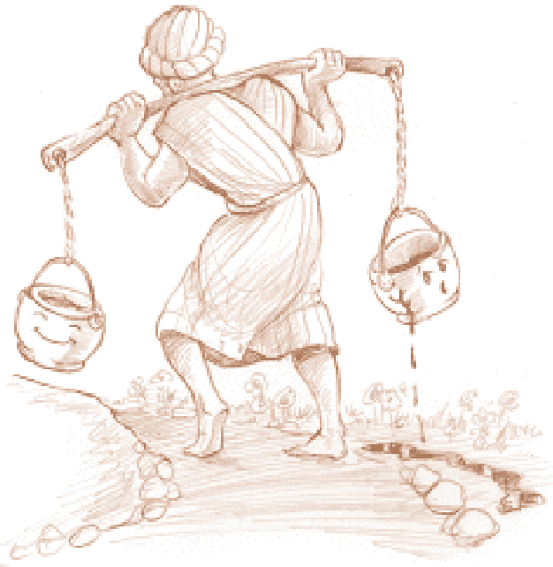

Once upon a time there was a water-bearer in India who had two large pots, each hung on each end of a pole which he carried across his neck. One of the pots had a crack in it, and while the other pot was perfect and always delivered a full portion of water at the end of the long walk from the stream to the master’s house, the cracked pot arrived only half full.

For a full two years this went on daily, with the bearer delivering only one and a half pot full of water in his master’s house.

Of course, the perfect pot was proud of its accomplishments, perfect to the end for which it was made. But the poor cracked pot was ashamed of its own imperfection, and miserable that it was able to accomplish only half of what it had been made to do.

After two years of what it perceived to be a bitter failure, it spoke to the water-bearer one day by the stream. “I am ashamed of myself, and I want to apologize to you.” “Why?” asked the bearer.

“What are you ashamed of ?”

“I have been able, for these past two years, to deliver only half my load because this crack in my side causes water to leak out all the way back to your master’s house. Because of my flaws, you have to do all of this work and you don’t get full value from your efforts, the pot said. The water-bearer felt sorry for the old cracked pot, and in his compassion he said, “As we return to the master’s house, I want you to notice the beautiful flowers along the path.”

Indeed, as they went up the hill, the old cracked pot took notice of the sun warming the beautiful wild flowers on the side of the path, and this cheered it some.

But at the end of the trail, it still felt bad because it had leaked out half its load, and so again it apologized to the bearer for its failure.

The bearer said to the pot, “Did you notice that there were flowers only on your side of your path, but not on the other pot’s side?

That’s because have always known about your flaw, and I took advantage of it. I planted flower seeds on your side of the path, and every day while we walk back from the stream, you’ve watered them. For two years I have been able to pick these beautiful flowers to decorate my master’s table. Without you being just the way you are, he would not have this beauty to grace his house.”

**Each of us has our own unique flaw. But it’s the cracks and flaws we each have that make our lives together so very interesting and warding. You’ve just got to take each person for what they are and look for the good in them.**

# GOD EXISTS

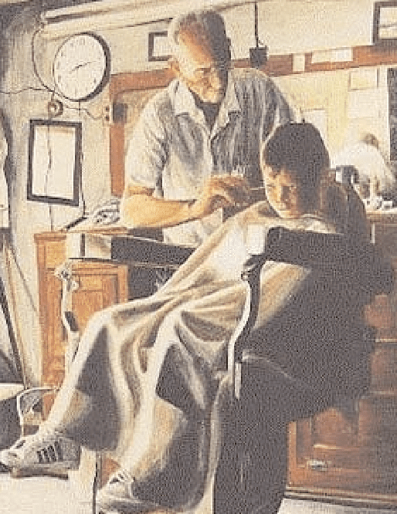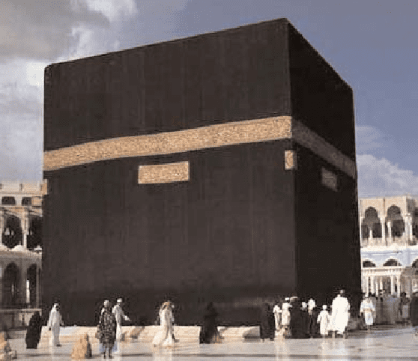

A man went to a barbershop to have his hair and his beard cut as always. He started to have a good conversation with the barber who attended him. They talked about so many things on various subjects.

Suddenly, they touched the subject of God. The barber said:

“Look man, I don’t believe that God exists as you say so.” “Why do you say that?”

Asked the client. Well, it’s so easy; you just have to go out in the street to realize that God does not exist. Oh, tell me, if God existed, would there be so many sick people? Would there be abandoned children? If God existed, there would be neither suffering nor pain. “I can’t think of a God who permits all of these things.” The client stopped for a moment thinking but he didn’t want to respond so as to prevent an argument.

The barber finished his job and the client went out of the shop.

Just after he left the barbershop, he saw a man in the street with a long hair and beard (it seems that it had been a long time since he had his cut and he looked so untidy). Then the client again entered the barbershop and he said to the barber: “know what? Barbers do not exist.”

“How come they don’t exist?” asked the barber. “Well I am here and I am a barber.” “No!” - the client exclaimed. “They don’t exist because if they did there would be no people with long hair and beard like that man who walks in the street.”

“Ah, barbers do exist, what happens is that people do not come to us.” “Exactly!” - Affirmed the client. “That’s the point. God does exist, what happens is people don’t go to Him and do not look for Him that’s why there’s so much pain and suffering in the world.”

# A BOY WITH STRONG BELIEF

Shaykh Fath al-Mowsily relates, once I saw a young boy walking through the jungle. It appeared as if he was uttering some words. I greeted him with Salaam and he replied accordingly. I inquired, “Where are you going?” He retorted, “To the house of Allah

(Makkah).” I further asked, “What are you reciting?” “The Qur’an” he replied. I remarked, “You are at a tender age, it is not an obligation that you are required to fulfill.”

He said, “I have witnessed death approach people younger than me and therefore would like to prepare if death was to knock on my door.” I astoundingly commented, “Your steps are small and your destination far.” He responded, “My duty is to take the step and it remains the responsibility of Allah to take me to my destination.” I continued to ask, “Where is your provision and conveyance (means of transport).”

He replied, “My Yaqeen (belief) is my provision and

my feet’s are my conveyance.” I explained, “I am asking you regarding bread and water.”

He replied! “Oh Shaykh if someone invited you to his house, would it be appropriate to take your own food?” I exclaimed, “No!” “Similarly, My Lord has invited His servant to His house, it is only the weakness of your Yaqeen that makes us carry provisions. Despite this, do you think Allah will let me go to waste?” “Never” I replied. He then left. Sometime later I saw him in Makkah. He approached me and inquired, “Oh Shaykh are you still of weak belief?”

Source: Stories of the Pious by Shaikh Ahmad Ali.

# A VERY POWERFUL STORY

He remembered his grandmother’s warning about praying on time: “My son, you shouldn’t leave prayer to this late time.” His grandmother’s age was 70 but whenever she heard the Adhan, she got up like an arrow and performed Salah/Namaz/prayer. He, however could never win over his ego to get up and pray. Whatever he did, his Salah was always the last to be offered and he prayed it quickly to get it in on time. Thinking of this, he got up and realized that there were only 15 minutes left before Salat-ul Isha. He quickly made Wudhu and performed Salat-ul Maghrib. While making Tasbih, he again remembered his grandmother and was embarrassed by how he had prayed. His grandmother prayed with such tranquility and peace. He began making Dua and went down to make Sajdah and stayed like that for a while.

He had been at school all day and was tired, so tired. He awoke abruptly to the sound of noise and shouting. He was sweating profusely. He looked around. It was very crowded. Every direction he looked in was filled with people. Some stood frozen looking around, some were running left and right and some were on their knees with their heads in their hands just waiting. Pure fear and apprehension filled him as he realized where he was.

His heart was about to burst. It was the Day of Judgment. When he was alive, he had heard many things about the questioning on the Day of Judgment, but that seemed so long ago. Could this be something his mind made up? No, the wait and the fear were so great that he could not have imag- ined this. The interrogation was still going on. He began moving frantically from people to people to ask if his name had been called. No one could answer him. All of a sudden his name was called and the crowd split into two and made a passageway for him. Two people grabbed his arms and led him forward. He walked with unknowing eyes through the crowd. The angels brought him to the center and left him there. His head was bent down and his whole life was passing in front of his eyes like a movie. He opened his eyes but saw only another world. The people were all helping oth- ers. He saw his father running from one lecture to the other, spending his wealth in the way of Islam. His mother invited guests to their house and one table was being set while the other was being cleared.

He pleaded his case; “I too was always on this path. I helped others. I spread the word of Allah.

I performed my Salah. I fasted in the month of Ramadan. Whatever Allah ordered us to do, I did. Whatever he ordered us not to do, I did not.” He began to cry and think about how much he loved Allah. He knew that whatever he had done in life would be less than what Allah deserved and his only protector was Allah. He was sweating like never before and was shaking all over. His eyes were fixed on the scale, waiting for the final decision. At last, the decision was made. The two angels with sheets of paper in their hands, turned to the crowd. His legs felt like they were going to collapse. He closed his eyes as they began to read the names of those people who were to enter Jahannam/Hell. His name was read first. He fell on his knees and yelled that this couldn’t be, “How could I go to

Jahannam? I served others all my life, I spread the word of Allah to others.” His eyes had become blurry and he was shaking with sweat. The two angels took him by the arms. As his feet dragged, they went through the crowd and advanced toward the blazing flames of Jahannam. He was yelling and wondered if there was any person who was going to help him. He was yelling of all the good deeds he had done, how he had helped his father, his fasts, prayers, the Qur’an that he read, he was asking if none of them would help him. The Jahannam angels continued to drag him. They had got- ten closer to the Hellfire. He looked back and these were his last pleas. Had not Rasulullah [saw] said, “How clean would a person be who bathes in a river five times a day, so too does the Salah performed five times cleanse someone of their sins?” He began yelling, “My prayers? My prayers?

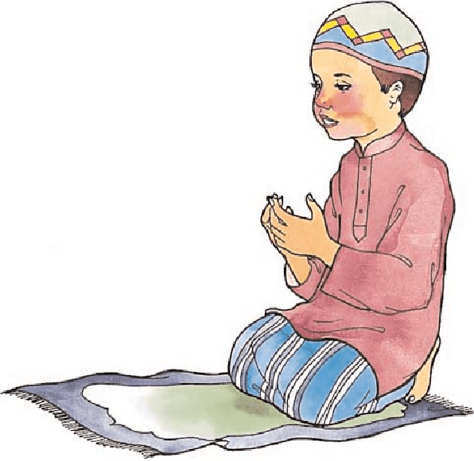

My prayers?”

The two angels did not stop, and they came to the edge of the abyss of Jahannam. The flames of the fire were burning his face. He looked back one last time, but his eyes were dry of hope and he had nothing left in him. One of the angels pushed him in.

He found himself in the air and falling towards the flames. He had just fallen five or six feet when a hand grabbed him by the arm and pulled him back. He lifted his head and saw an old man with a long white beard. He wiped some dust off himself and asked him,

“Who are you?” The old man replied, “I am your prayers.”

“Why are you so late! I was almost in the Fire! You rescued me at the last minute before I fell in.”

The old man smiled and shook his head. “You always performed me at the last minute, and did you forget?” At that instant, he blinked and lifted his head from Sajdah. He was in a sweat. He listened to the voices coming from outside. He heard the adhan for Salat-ul Isha. He got up quickly and went to perform Wudhu.

**“Say Your Prayers Before Prayers For You Are Said.” “Namaz Parh Is Se Pehle Ke Teri Namaz Parhi Jaye.”**

# WORDS AND ACTIONS SHOULD BE THE SAME

There once was a boy who loved eating sweets. He always asked for sweets from his father. His father was a poor man. He could not always afford sweets for his son. But the little boy did not understand this, and demanded sweets all the time.

The boy’s father thought hard about how to stop the child asking for so many sweets. There was a very holy man living nearby at that time. The boy’s father had an idea. He decided to take the boy to the great man who might be able to persuade the child to stop asking for sweets all the time.

The boy and his father went along to the great man. The father said to him, “O great saint, could you ask my son to stop asking for sweets which I cannot afford?” The great man was in difficulty, because he liked sweets himself. How could he ask the boy to give up asking for sweets? The holy man told the father to bring his son back after one month.

During that month, the holy man gave up eating sweets, and when the boy and his father returned

after a month, the holy man said to the boy “My dear child, will you stop asking for sweets which your father cannot afford to give you?”

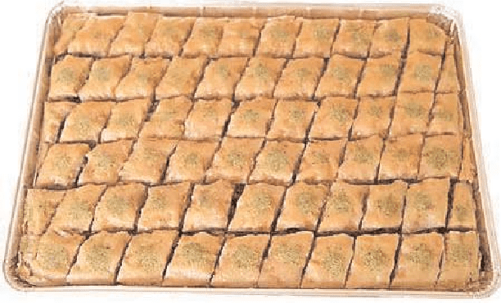

From then on, the boy stopped asking for sweets.

The boy’s father asked the saint, “Why did you not ask my son to give up asking for sweets when we came to you a month ago?” The saint replied, “How could I ask a boy to give up sweets when I loved sweets myself. In the last month I gave up eating sweets.” A person’s example is much more powerful than just his words. When we ask

someone to do something, we must do it ourselves also. We should not ask others to do what we do not do ourselves.

**Always make sure that your actions and your words are same.**

# YOU'RE FAR MORE PRECIOUS THAN DIAMONDS AND PEARLS

“If memory serves me correctly, I was wearing a little white tank top and a short black skirt. I had been raised Orthodox Muslim, so I had never before worn such revealing clothing while in my father’s presence. When we finally arrived, the chauffer escorted my younger sister, Laila, and me up to my father's suite.

As usual, he was hiding behind the door waiting to scare us. We exchanged many hugs and kisses as we could possibly give in one day. My father took a good look at us. Then he sat me down on his lap and said something that I will never forget.

He looked me straight in the eyes and said, “Hana, everything that God made valuable in the world is covered and hard to get to. Where do you find diamonds? Deep down in the ground covered and protected. Where do you

find pearls? Deep down at the bottom of the ocean covered up and protected in a beautiful shell. Where do you find gold? Way down in the mine, covered over with layers and layers of rock.

You’ve got to work hard to get to them.”

He looked at me with serious eyes. “Your body is sacred. You’re far more precious than diamonds and pearls, and you should be covered too.”

Source: More Than A Hero: Muhammad Ali’s Life Lessons Through His Daughter’s Eyes.

# THE ONE-EYED DOE

A Doe had the misfortune to lose one of her eyes, and could not see any one approaching her on that side. So to avoid any danger she always used to feed on a high cliff near the sea, with her sound eye looking towards the land. By this means she could see whenever the hunters approached her on land, and often escaped by this means. But the hunters found out that she was blind of one eye, and hiring a boat rowed under the cliff where she used to feed and shot her from the sea. “Ah,” cried she with her dying voice. **“You cannot escape your fate.”**

# THE CAGE BIRD'S ESCAPE

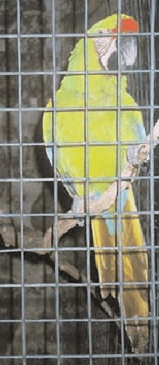

Once upon a time, there was a bird in a cage who sang for her merchant owner. He took delight in her song day and night, and was so fond of her that he served her water in a golden dish. Before he left for a business trip, he asked the bird if she had a wish: “I will go through the forest where you were born, past the birds of your old neighborhood. What message should I take for them?”

The bird said, “Tell them I sit full of sorrow in a cage singing my captive song. Day and night, my heart is full of grief. I hope it will not be long before I see my friends again and fly freely through the trees. Bring me a message from the lovely forest, which will set my heart at ease. Oh, I yearn for my Beloved, to fly with him, and spread my wings. Until then there is no joy for me, and I am cut off from all of life’s sweet things.”

The merchant traveled on his donkey through the dense forest. He listened to the melodies of many birds. When the merchant reached the forest where his bird came from, he stopped, pushed his hood back, and said, “O you birds! Greetings to you all from my pretty bird locked in her cage. She sends tidings of her love to you and wants to tell of her plight. She asks for a reply that will ease her heart. My love for her keeps her captive with bars all around her. She wants to join her Beloved and sing her songs through the air with a free heart, but I would miss her beautiful songs and cannot let her go.”

All the birds listened to the merchant’s words. Suddenly one bird shrieked and fell from a tree brunch to the ground. The merchant froze to the spot where he stood. Nothing could astound him more than this did. One bird had fallen down dead!

The merchant continued on to the city and traded his goods. At last he returned to his home.

He did not know what to tell his bird when she asked what message he had brought. He stood before her cage and said, “Oh, nothing to speak of no, no.” The bird cried, “I must know at once.”

I do not know what happened, said the merchant. “I told them your message. Then, one of them fell down dead.” Suddenly the merchant’s bird let out a terrible shriek and fell on her head to the bottom of the cage. The merchant was horrified. He wept in despair, “Oh, what have I done?”

He cried, “What Have I done? Now my life means nothing. My moon has gone and so has my sun. Now my own bird is dead.”

He opened the cage door, reached in, and took her into his hands gently and carefully. “I will have to bury her now,” he said; “poor thing is dead.”

Suddenly, the moment he had lifted the bird out of the cage, she swooped up, flew out of the window and landed on the nearest roof slope. She turned to him and said, gratefully, “Thank you, merchant master, for delivering my message. That bird’s reply instructed me how to win my freedom. All I had to do was to be dead. I gained my freedom when I chose to die.”

“So now I fly to my Beloved who waits for me. Good-bye, good-bye, my master no longer.” “My bird was wise; she taught me secret,” the merchant reflected.

**If you want to be with the ones you love, you must be ready to give up everything, even life itself. And then, by Allah, you will win your heart’s desire.**

# THE THREE WISE MEN

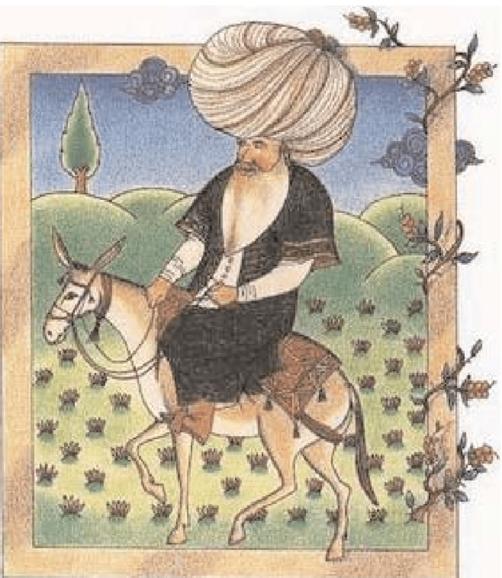

One day some wise men, who were going about the country trying to find answers to some of the great questions of their time, came to Nasreddin’s district and asked to see the wisest man in the place. Nasreddin was brought forward, and a big crowd gathered to listen.

The first wise man began by asking, “Where is the exact center of the world?”

“It is under my right heel,” answered Nasreddin. “How can you prove that?” asked the first wise man.

“If you don’t believe me,” answered Nasreddin, “measure and see.”

The first wise man had nothing to answer to that, so the second wise man asked his question. “How many stars are there in the sky?” he said. “As many as there are hairs on my donkey,” answered Nasreddin.

“What proof have you got of that?” asked the second wise man.

“If you don’t believe me,” answered Nasreddin, “count the hairs on my donkey and you will see.” “That’s foolish talk,” said the other. “How can one count the hairs on a donkey?”

“Well,” answered Nasreddin, “How can one count the stars in the sky? If one is foolish talk, so is the other.” The second wise man was silent.

The third wise man was becoming annoyed with Nasreddin and his answers, so he said, “You seem to know a lot about your donkey, so can you tell me how many hairs there are in its tail?”

“Yes,” answered Nasreddin. “There are exactly as many hairs in its tail as there are in your beard.” “How can you prove that?” said the other.

“I can prove it very easily,” answered Nasreddin. “You can pull one hair out of my donkey’s tail for every one I pull out of your beard. If the hairs on my donkey’s tail do not come to an end at exactly the same time as the hairs in your beard, I will admit that I was wrong.”

Of course, the third wise man was not willing to do this, so the crowd declared Nasreddin the winner of the day’s arguments.

# OLD GRAVE

One day, the Nasreddin said to his friends: “If I die, bury me in an old grave.” “Why”, asked his friends. “Because”, he explained, “if the angels come, I’ll tell them that I died years before and have already been questioned and then they will return the way they came.”

# THE CLEVER BOY

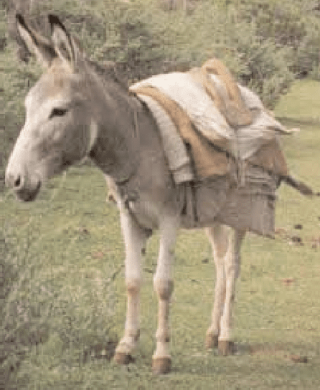

A man with his donkey carrying two sacks of wheat was on his way to the market. After a little while he was tired and they rested under a tree. When he woke up from his nap he could not see the donkey and started searching for the donkey everywhere. On the way he met a boy, he asked the boy, “Have you seen my donkey?” The boy asked, “Is the donkey’s left eye blind, his right foot lame and is he carrying a load of wheat?” The man was happy and said, “Yes, exactly! Where have you seen it?” the boy answered “I haven’t seen it.” This made the man very angry and he took the boy to the village chief for punishment.

The judge asked, “Dear boy, if you had not seen at the donkey, how could you describe it?” The boy answered, “I saw the tracks of a donkey and the right and left tracks were different from this I understood that the donkey that passed there was limping. And the grass on the right side of the road was eaten but the grass on the left was not. From that I understood that his left eye was blind. There were wheat seeds scattered

on the ground and I understood that he must have been carrying a load of wheat. The judge understood the boy’s cleverness and told the man to forgive the boy.

**This story teaches us that we should not be quick to judge the people.**

# A MERCHANT AND HIS DONKEY

One beautiful spring morning, a merchant loaded his donkey with bags of salt to go to the market in order to sell them. The merchant and his donkey were walking along together. They had not walked far when they reached a river on the road.

Unfortunately, the donkey slipped and fell into the river and noticed that the bags of salt loaded on his back became lighter.

There was nothing the merchant could do, except return home where he loaded his donkey with more bags of salt. As they reached the slippery riverbank, now deliberately, the donkey fell into the river and wasted all the bags of salt on its back again.

The merchant quickly discovered the donkey’s trick. He then returned home again but re-loaded his donkey with bags of sponges.

The foolish, tricky donkey again set on its way. On reaching the river he again fell into the water. But instead of the load becoming lighter, it became heavier.

**The merchant laughed at him and said: “You foolish donkey, your trick had been discovered, you should know that,**

**those who are too clever sometimes over reach themselves.”**

# THE ANT AND THE GRASSHOPPER

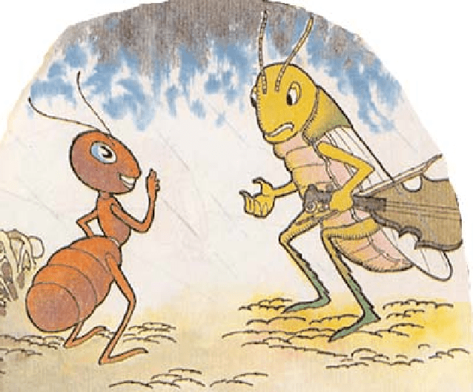

One cold, frosty day in the middle of winter a colony

of ants was busy drying out some, grains of corn, which had grown damp during the wet autumn weather.

A grasshopper half dead with cold and hunger, came up to one of the ants. “Please give me a grail or two from your store of corn to save my life,” he said faintly.

“We worked day and night to get this corn in.

Why should I give it to you?” asked the ant crossly. “Whatever were you doing all last summer when you should have been gathering your food?”

Oh I didn’t have time for things like that, said the grasshopper. “I was far too busy singing to carry corn about.”

The ant laughed I unkindly. “In that case you can sing all winter as far as I am concerned,” he said. And without another word he turned back to his work.

**Islam teaches us that we should help the less fortunate. But it also teaches us that we must work hard and not rely on the kindness of others for our daily needs.**

# THE FOX WHO GOT CAUGHT IN THE TREE TRUNK

Once upon a time, there was a hungry fox that was looking for something to ear. He was very hungry. No matter how hard he tried, the fox could not find food. Finally he went to the edge of the forest and searched there for food. Suddenly he caught sight of a big tree with a hole in it.

Inside the hole was a package. The hungry fox immediately thought that there might be food in it, and he became very happy. He jumped into the hole and when he

opened the package, he saw there were a lot of food, bread, meat and fruit in it!

An old woodcutter had placed the food in the tree trunk while he cut down trees in the forest. He was going to eat it for his lunch.

The fox happily began to eat. After the fox had finished eating, he felt thirsty and decided to leave the trunk and drink some water from a nearby spring. However, no matter how hard he tried, he could not get out of the hole. Do you know why? Yes, the fox had eaten so much food that he became too big to fit through the hole.

The fox was very sad and upset. He told himself, “I wish that I had thought a little before jumping into the hole.”

**Yes children, this is the result of doing something without thinking about it first.**

# CATS AND ROOSTERS

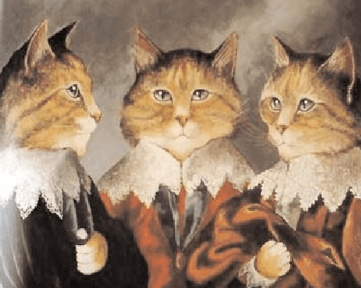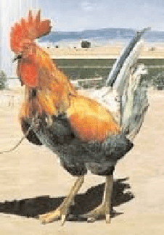

Once upon a time in Africa, roosters ruled cats. The cats worked hard all day and at night they had to bring all they had gathered for the roosters. The king of the roosters would take all the food for himself and for the other roosters.

The roosters loved to eat ants. Thus, every cat had a purse hung round its neck, which it filled with ants for the king of the roosters. The cats did not like the situation. They wanted to rid themselves of the king so that the food they gathered through hard work and great difficulty would be their own. But they were afraid of the roosters.

The roosters had told the cats that rooster’s combs were made out of fire and that the fire of their combs would burn anyone who disobeyed them! The cats believed them and therefore worked from early morning until night for the roosters.

One night, the fire on the house of Mrs. Cat went out. She told her kitten, Fluffy, to bring some fire from Mr. Rooster’s house. When Fluffy went into the house of the rooster, she saw that Mr. Rooster was fast asleep, his stomach swollen with the ants he had eaten. The kitten was afraid to wake the rooster, so she returned home empty handed and told her mother what had happened.

Mrs. Cat said, “Now that the rooster is asleep, gather some dry twigs and place them near his comb. As soon as the twigs catch fire, bring them home.”

Fluffy gathered some dry twigs and took them to the rooster’s house. He was still asleep. Fluffy fearfully put the dry twigs near the rooster’s comb but it was no use, the twigs did not catch fire. Fluffy rubbed the twigs against the rooster’s comb again but it was no use they would not catch fire. Fluffy returned home without any fire and told her mother, “The roost’s comb does not set twigs on fire.” Mrs. Cat answered “Why can’t you do anything right! Come with me I’ll show you how to make fire with the rooster’s comb.” So together they went to the house of Mr. Rooster.

He was still asleep. Mrs. Cat put the twigs as near to the rooster’s comb as she could. But the twigs did not catch fire. Then, shaking with fear, she put her paw near the rooster’s comb and gently touched it. To her surprise, the comb was not hot, it was very cold, and it was just red colored.

As soon as Mrs. Cat realized that the roosters had lied to the cats about their combs, she joyfully went out and told the other cats about the rooster’s tricks. From that day on, the cats no longer worked for the roosters.

At first, the king of the roosters became very angry and said to the cats; “I will burn all of your houses if you do not work for me!”

But the cats said, “Your comb is not made of fire. It is just the color of fire. We touched it when you were sleep. You lied to us.”

**When the king of the roosters found out that the cats knew that he had lied to them, he ran away. Now, whenever roosters see a cat, they scurry away, because to this very day they are afraid of cats.**

# THE PROUD RED ROSE

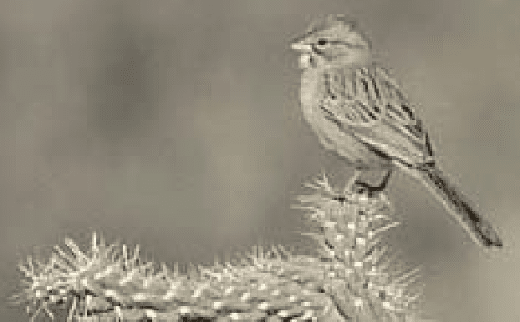

One beautiful spring day a red rose blossomed in a forest. Many kinds of trees and plants grew there. As the rose looked around,

a pine tree nearby said, “What a beautiful flower. I wish I was that lovely.” Another tree said, “Dear pine, do not be sad, we can not have everything.”

The rose turned its head and remarked, “It seems that I am the most beautiful plant in this forest.” A sunflower raised its yellow head and asked, “Why do you say that? In this forest there are many beautiful plants. You are just one of them.” The red rose replied, “I see everyone looking at me and admiring me.” Then the rose looked at a cactus and said, “Look at that ugly plant full of thorns!” The pine tree said, “Red rose, what kind of talk is this? Who can say what beauty is? You have thorns too.”

The proud red rose looked angrily at the pine and said, “I thought you had good taste! You do not know what beauty is at all. You can not compare my thorns to that of the cactus.”

“What a proud flower”, thought the trees.

The rose tried to move its roots away from the cactus, but it could not move. As the days passed, the red rose would look at the cactus and say insulting things, like: This plant is useless?

How sorry I am to be his neighbor.

The cactus never got upset and he even tried to advise the rose, saying, “God did not create any form of life without a purpose.”

Spring passed, and the weather became very warm. Life became difficult in the forest, as the plants and animals needed water and no rain fell. The red rose began to wilt. One day the rose saw sparrows stick their beaks into the cactus and then fly away, refreshed. This was puzzling, and the red rose asked the pine tree what the birds were doing. The pine tree explained that the birds got water from the cactus. “Does it not hurt when they make holes?” asked the rose.

“Yes, but the cactus does not like to see any birds suffer,” replied the pine. The rose opened its eyes in wonder and said, “The cactus has water?” “Yes you can also drink from it. The sparrow can bring

water to you if you ask the cactus for help.”

The red rose felt too ashamed of its past words and behavior to ask for water from the cactus, but then it finally did ask the cactus for help. The cactus kindly agreed and the birds filled their beaks with water and watered the rose’s roots. Thus the rose learned a lesson and never judged anyone by their appearance again.

# THE SELFISH MAN



Once upon a time, there was a selfish man. He liked everything to be his own. He could not share his belongings with anyone, not even his friends or the poor.

One day, the man lost thirty gold coins. He went to his friend’s house and told him how he lost his gold coins. His friend was a kind man.

As his friend’s daughter was coming from an errand she found thirty gold coins, when she arrived home, she told her father what she had found. The girl’s father told her that the gold coins belong to his friend and he sent for him. When the selfish man arrived, he told him how his daughter had found his thirty gold coins and handed then to him. After counting the gold coins the man said that ten of them was missing and had been taken by the girl as he had forty gold coins. He further commented that he will recover the remaining amount from him. But the girl’s father refused.

The man left the gold coins and went to the court and informed the judge there about what had taken place between him and the girl’s father.

The judge sent for the girl and her father, and when they arrived asked the girl how many gold coins did she find. She replied thirty gold coins. The Judge that asked the selfish man how many gold coins did he lose and he answered forty gold coins.

The judge then told the man that the gold coins did not belong to him because the girl found thirty and not forty as he claimed to have lost and then told the girl to take the gold coins and that if any- body is looking for them he will send for the girl.

The judge told the man that if anybody reports that they have found forty gold coins he will send for him. It was then that the man confessed that he lied and that he lost thirty gold coins but the judge did not listen to him.

**This story teaches us to be always honest as dishonest never pays.**

**YOU ARE PRICELESS TO THOSE WHO LOVE YOU**

A well-known speaker started off his seminar by holding up a $20 bill. In the room of 200, he asked, “Who would like this $20 bill?” Hands started going up. He said,

“I am going to give this $20 to one of you but first, let me do this.” He proceeded to crumple up the $20 bill. He asked, “Who still wants it?” Still hands were up in the air.

“Well, what if I do this?” He dropped it on the ground and started to grind it into the floor with his shoe. He picked it up, now crumpled and dirty and asked, “Who still wants it?” Still hands went up into the air.

My friends, we have all learned a very valuable lesson. No matter what was done to the money, it was still wanted because it did not decrease in value. It was still worth

$20. Many times in our lives, we are dropped, crumpled and ground into the dirt by the decisions we make and the circumstances that come our way. We may feel as though we are worthless.

But no matter what has happened or will happen, you will never lose your value: dirty or clean, crumpled or finely creased, you are still priceless to those who love you.

# BE CAREFUL WHAT YOU PLANT



An emperor in the Far East was growing old and knew it was time to choose his successor. Instead of choosing one of his assistants or his children, he decided something different.

He called young people in the kingdom together one day. He said, “It is time for me to step down and choose the next emperor. I have decided to choose one of you.”

The kids were shocked! But the emperor continued. “I am going to give each one of you a seed today. One very special seed. I want you to plant the seed, water it and come back here after one year from today with what you have grown from this one seed. I will then judge the plants that you bring, and the one I choose will be the next emperor!”

One boy named Ling was there that day and he, like the others, received a seed. He went home and excitedly told his mother the story. She helped him get a pot and planting soil, and he planted the seed and watered it carefully. Every day he would water it and watch to see if it had grown. After about three weeks, some of the other youths began to talk about their seeds and the plants that were beginning to grow.

Ling kept checking his seed, but nothing ever grew. 3 weeks, 4 weeks, 5 weeks went by. Still nothing. By now, others were talking about their plants but Ling didn't have a plant, and he felt like a failure. Six months went by, still nothing in Ling’s pot. He just knew he had killed his seed. Everyone else had trees and tall plants, but he had nothing. Ling didn’t say anything to his friends, however. He just kept waiting for his seed to grow.

A year finally went by and all the youths of the kingdom brought their plants to the emperor for inspection. Ling told his mother that he wasn’t going to take an empty pot. But honest about what happened, Ling felt sick to his stomach, but he knew his mother was right. He took his empty pot to the palace. When Ling arrived, he was amazed at the variety of plants grown by the other youths. They were beautiful in all shapes and sizes. Ling put his empty pot on the floor and many of the other kinds laughed at him. A few felt sorry for him and just said, “Hey nice try.”

When the emperor arrived, he surveyed the room and greeted the young people. Ling just tried to hide in the back. “What great plants, trees and flowers you have grown,” said the emperor. “Today, one of you will be appointed the next emperor!” All of a sudden, the emperor spotted Ling at the back of the room with his empty pot. He ordered his guards to bring him to the front. Ling was terrified. “The emperor knows I’m a failure! Maybe he will have me killed!”

When Ling got to the front, the Emperor asked his name. “My name is Ling,” he replied. All the kids were laughing and making fun of him. The emperor asked everyone to quiet down. He looked at Ling, and then announced to the crowd, “Behold your new emperor! His name is Ling!” Ling couldn’t believe it. Ling couldn’t even grow his seed. How could he be the new emperor? Then the emperor said, “One year ago today, I gave everyone here a seed. I told you to take the seed, plant it, water it, and bring it back to me today. But I gave you all boiled seeds, which would not grow.

All of you, except Ling, have brought me trees and plants and flowers. When you found that the seed would not grow, you substituted another seed for the one I gave you. Ling was the only one with the courage and honesty to bring me a pot with my seed in it. Therefore, he is the one who will be the new emperor!”

If you plant honesty, you will reap trust.

If you plant goodness, you will reap friends. If you plant humility, you will reap greatness.

If you plant perseverance, you will reap victory.

If you plant consideration, you will reap harmony. If you plant hard work, you will reap success.

If you plant forgiveness, you will reap reconciliation. If you plant openness, you will reap intimacy.

If you plant patience, you will reap improvements. If you plant faith, you will reap miracles.

But

If you plant dishonesty, you will reap distrust.

If you plant selfishness, you will reap loneliness. If you plant pride, you will reap destruction.

If you plant envy, you will reap trouble.

If you plant laziness, you will reap stagnation. If you plant bitterness, you will reap isolation. If you plant greed, you will reap loss.

If you plant gossip, you will reap enemies. If you plant worries, you will reap wrinkles. If you plant sin, you will reap guilt.

**“Remember your graves because your way passes over it. You will be dealt with as you deal with others, you will reap what you sow, and what you send today will meet you tomorrow.” Imam Ali (AS)**

So be careful what you plant now, It will determine what you will reap tomorrow, The seeds you now scatter, Will make life worse or better, your life or the ones who will come after. Yes, someday, you will enjoy the fruits, or you will pay for the choices you plant today.

# GENEROSITY

Mahatma Gandhi went from city to city, village to village collecting funds for the Charkha Sangh. During one of his tours he addressed a meeting in Orissa.

After his speech a poor old woman got up. She was bent with age, her hair was grey and her clothes were in tatters. The volunteers tried to stop her, but she fought her way to the place where Gandhi Ji was sitting.

“I must see him,” she insisted and going up to Gandhi Ji touched his feet.

Then from the folds of her sari she brought out a copper coin and placed it at his feet. Gandhi Ji picked up the copper coin and put it away carefully. The Charkha Sangh funds were under the charge of Jamnalal Bajaj. He asked Gandhi Ji for the coin but Gandhi Ji refused.

“I keep cheques worth thousands of rupees for the Charkha Sangh,” Jamnalal Bajaj said laughingly “yet you won’t trust me with a copper coin.” “This copper coin is worth much more than those thousands” Gandhi Ji said. “If a man has several lakhs and he gives away a thousand or two,

it doesn’t mean much.”

But this coin was perhaps all that the poor woman possessed. She gave me all she had. That was very generous of her. What a great sacrifice she made. That is why I value this copper coin more than a crore of rupees.

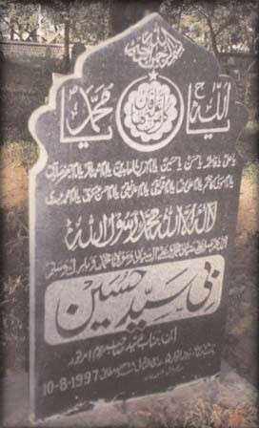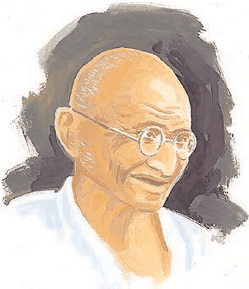

**"Overlook and forgive the weakness of generous people, because if they fall down, Allah gives his hand in their hands and helps them…." Imam Ali (AS)**

# THE CRYSTAL BALL



In the south of Spain, there was a small village whose people were very joyful and lucky. The children played under the shade of trees in the gardens of their home. A shepherd boy whose name was Nasir, stayed near the village with his father, mother and grandmother. Early morning each day, he takes his herd of goats up the hills to find a suitable place for them to graze. In the afternoon he would return with them to the village. At night his grandmother would tell him a story. The story of stars. This story really interested Nasir. As usual, on one of these days, as Nasir was watching his herd and playing his flute he suddenly saw a wonderful light behind the flower bush. When he came towards the branches he saw a transparent and most beautiful crystal ball.

The crystal ball was glittering like a colorful rainbow. Nasir carefully took it in his hand and turned it around. With surprise suddenly he heard a weak voice coming from the crystal ball. It said; “You can make a wish that your heart desires and I will fulfill it.” Nasir could not believe that he had actually heard a voice. But he became so engrossed in his thoughts for he had so many wishes but he must wish for something which was impossible like the wish to be able to fly. He said to himself, if I wait till tomorrow I will remember many

things. He put the crystal ball in a bag and gathered the herd, happily returned back

to the village. He decided that he would not tell anyone about the crystal ball. On the following day also, Nasir could not decide what to wish for, because he really had everything he needed.

The days passed as usual, and Nasir appeared to be very cheerful that the people around him were amazed to see his cheerful disposition. One day a boy followed Nasir and his herd and hid behind

a tree. Nasir as usual sat in one corner, took out the crystal ball and for a few moments looked at it. The boy waited for the moment when Nasir would go to sleep. Then he took the crystal ball and ran away. When he arrived in the village, he called all the people and showed them the crystal ball.

The citizens of that village took the crystal ball in their hand and turned it around with surprise. Suddenly they heard a voice from inside the crystal ball, which says, “I can fulfill your wish.” One person took the ball and screamed, “I want one bag full of gold.” Another took the ball and said loudly, “I want two chest full of jewelry.”

Some of them wished that they would have their own palace with grand door made from pure gold instead of their old houses. Some also wished for bags full of jewelry, but nobody asked for gardens in their palaces. All their wishes were fulfilled but still the citizens of the village were not happy.

They were jealous because the person that had a palace had no gold and the person that had the gold had no palace. For this reason, the citizens of the village were angry and were not speaking to each other. There was not even one garden which existed in the village where the children could play. The patience of the children was running out and they were uncomfortable. Nasir and his family were happy and pleased. Every morning and afternoon he would play the flute.

The children could not wait anymore and decided to return the crystal ball to Nasir. The parents and neighbors went to him. The children said to Nasir; “When we had a small village we all were happy and joyful.” The parent also spoke. In one way or another nobody is happy. The expensive palaces and jewelry only bring us pain. When Nasir saw that the people were really regretful, he said I have not wished till now, if you really want everything to return to its own place, then I will wish for it. Everyone happily agreed. Nasir took the crystal ball in his hand turned around and wished that the village become the same as it was before. Everyone quickly turned towards the village and saw it became the same old village with gardens full of trees and fruits.

Once again the people started to live happily and the children played under the shade of trees. From the next day and everyday at sunset the sound of Nasir’s flute could be heard in the village.



**This story teaches us that we should be happy with whatever we have and not to be greedy.**

# THE SIGNS OF HAPPINESS

There was a young couple who led a very happy life together. The only thing that they worried about was, whether their happiness would last forever or would they too would have to face problems. One day, they heard that a wise old man had come to town; he could solve all kinds of problems and guide people. So the couple decided to visit the wise old man and tell him their source of worry.

The wise old man told them; “Travel around the world and seek a man and a woman who are perfectly happy as a couple. When you find such a couple, ask them for a piece of cloth from the man’s shirt, then keep that piece of cloth with you, and you always remain happy.”

The young couple began their journey, to find the happiest couple in their world. In one place they heard that the governor and his wife were the happiest people, so they went to their palace and asked them, “Are you the happiest couple?”

The governor and his wife replied, “Yes, we are happy in every way except for one thing; we do not have any children.”

Well that didn’t make the governor and his wife the happiest couple. So they continued their journey. They arrived in one city where they had heard that the happiest couple lived.

They went to their house and asked them, “Are you the happiest couple?”

The couple replied, “Yes, we are really happy in every way except that we have too many children which make our life a bit uncomfortable.”

No, this couple did not sound to be the happiest. And, so they continued their journey. They visited many countries, cities, towns and villages asking the same

question but they did not find what they were looking for.

One Day the young couple came across a shepherd in the desert. The shepherd was grazing his sheep when his wife and child came along. The shepherd greeted his wife and gently patted

the child she was carrying. She laid the mat and started to eat contentedly. The young couple came to them and asked them, “Are you the happiest couple?”

The shepherd and his wife replied, “Nobody is unhappier than the king.” The young couple immediately realized that they were the happiest couple and asked them for a piece of the shepherd’s shirt, so that their happiness too would last throughout.

The shepherd said, “If I give you a piece of cloth from my shirt then I will be left without any clothes since I own just one shirt.”

The young couple at once understood that it is very difficult to

find perfect happiness anywhere in the world. The couple decided to return to their own country.

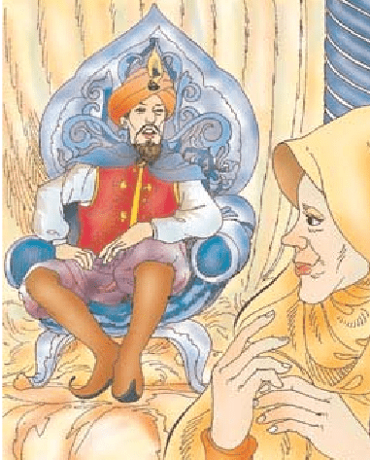

They went to the wise old man and related all that had taken place. They also complained that his guidance was difficult to abide by.

The wise old man laughed and said, “Was your journey useless or did you learn something from it?”

The young man replied, “Yes, after this trip I have learnt that in this world, nobody is perfectly happy, only that person is happy who does everything to please God.”

Holy Quran (2:38) says:

“And whosever follows My (Allah’s) guidance, on them shall be no fear nor shall they grieve.”

The wife said, “I have learnt that in order to be happy it is important to remember two things; first, all human beings should be thankful and contented with whatever they have.”

Holy Quran (14:7) says:

“And your Lord declared publicly: if you are grateful, I will add more favors unto you.” And secondly, for ultimate happiness one must always practice patience.

Holy Quran (2:45) says: “Seek help through patient perseverance and prayers.”

After that, young couple thanked the wise old man for his guidance and returned home. The wise man prayed for them and said, “Indeed the sign of happiness is in their heart and they have good manners and if the lifetime is spent in pleasure of God there would be no differences in the exis- tence of mankind.”

**Holy Quran (20:123-124) says: “Whosoever follows My (Allah’s) guidance, will not loose his way or fall into misery But whosoever turns away from My message, verily for him is a miserable life.”**

# HOPE AND GREED

Caliph Haroon Rashid desired that any one who had seen the Holy Prophet (SAW) in his lifetime be brought before him. After some time a very old woman was brought before the Caliph. The Caliph asked the old woman, “Did you see the Prophet yourself?” She said, “Yes! Sir.” The Caliph then asked her if she remembered any narration from him. She said yes and said, “When old age comes two things become young,

one is hope and the other is greed.” The Caliph thanked her and gave her one hundred dinars. The woman thanked Caliph and she was taken back.

Half the way some thought passed through her mind and she desired

to be brought before the Caliph once more. When she was shown in, the Caliph asked, “Well, why have you come back?” She said. “I just came to

inquire whether the monies you gave me were once for all or is it to continue every year?”

The Caliph thought. “How true is the Prophet’s (SAW) word?” she has hope of life even now and she has greed for money too. The Caliph said, “Don’t worry; you will be paid every year.”

She was taken back but on the way she breathed her last.

# FOUR WIVES



Once upon a time. There was a rich merchant who had 4 wives. He loved the 4th wife the most and adorned her with rich robes and treated her to delicacies. He took great care of her & gave her nothing but the best.

He also loved the 3rd wife very much. He’s very proud of her and always wanted to show off her to his friends. However, the merchant is always in fear that she might run away with some other men.

He too, loved his 2nd wife. She is a very considerate person, always patient & in fact is the merchant’s confidante. Whenever the merchant faced some problems, he always turned to his 2nd wife and she would always help him out and tide him through difficult times.

Now, the merchant’s 1st wife is a very loyal partner and has made great contributions in maintaining his wealth and business as well as taking care of the household. However, the merchant did not love the 1st wife and although she loved him deeply, he hardly took notice of her.

One day, the merchant fell ill. Before long, he knew that he was going to die soon. He thought of his luxurious life and told himself, “Now I have 4 wives with me. But when I die, I’ll be alone. How lonely I’ll be!” Thus, he asked the 4th wife, “I loved you most, endowed you with the finest clothing and showered great care over you. Now that I’m dying, will you follow me and keep me company?”

“No way!” replied the 4th wife and she walked away without another word. Answer cut like a sharp knife right into the merchant’s heart.

The sad merchant then asked the 3rd wife, “I have loved you so much for all my life. Now that I’m dying, will you follow me and keep me company?”

“No!” replied the 3rd wife. “Life is so good over here! I’m going to remarry when you die!” The merchant’s heart sank and turned cold.

He then asked the 2nd wife, “I always turned to you for help and

you’ve always helped me out. Now I need your help again. When I die, will you follow me and keep me company?” “I’m sorry, I can’t help you out this time!” replied the 2nd wife.” “At the very most, I can only send you to your grave.” Answer came like a bolt of thunder & merchant was devastated.

Then a voice called out: “I’ll leave with you. I’ll follow you no matter where you go.” The merchant looked up and there was his 1st wife. She was so skinny, almost like she suffered from malnutrition.

Greatly grieved, the merchant said, “I should have taken much better care of you while I could have!”

Actually, we all have 4 wives in our lives. The 4th wife is our body. No matter how much time and effort we lavish in making it look good, it’ll leave us when we die.

Our 3rd wife is our possessions, status and wealth. When we die, they all go to others.



The 2nd wife is our family and friends. No matter how close they had been there for us when we’re alive, the furthest they can stay by us is up to the grave.

The 1st wife is in fact our soul, often neglected in our pursuit of material wealth & sensual pleasure.

**Guess what? It is actually the only thing that follows us wherever we go. Perhaps it’s a good idea to cul- tivate and strengthen it now rather than to wait until we’re on our deathbed to lament.**

# LION, RATS, SNAKE & THE HONEYCOMB

Once a man saw in his dream, that a lion was chasing him. The man ran to a tree, climbed on to it and sat on a branch. He looked down and saw that the lion was still there waiting for him.

The man then looked to his side where the branch he was sitting on was attached to the tree and saw that two rats were circling around and eating the branch. One rat was black and the other one was white. The branch would fall on the ground very soon.

The man then looked below again with fear and discovered that a big black snake had come & settled directly under him. Snake opened its mouth right under the man so that he will fall into it.

The man then looked up to see if there was anything that he could hold on to. He saw another branch with a honeycomb. Drops of honey falling from it.

The man wanted to taste one of the drops. So, he put his tongue out and tasted one of the fallen drops of honey. The honey was amazing in taste. So, he wanted to taste another drop. As he did, he got lost into the honey sweetness.

Meanwhile, he forgot about the two rats eating his branch away, the lion on the ground and the snake that is sitting right under him. After a while, he woke up from his sleep.

To get the meaning behind this dream, the man went to a pious scholar of Islam. The scholar said, the lion you saw is your death. It always chases you and goes wherever you go.

The two rats, one black and one white, are the night and the day. Black one is the night and the white one is the day. They circle around, coming one after another, to eat your time as they take you closer to death. The big black snake with a dark mouth is your grave. It’s there, just waiting for you to fall into it. The honeycomb is this world and the sweet honey is the luxuries of this world.

We like to taste a drop of the luxuries of this world but it’s very sweet. Then we taste another drop and yet another.

**Meanwhile, we get lost into it and we forget about our time, we forget about our death and we forget about our graves.**

**“This world is like a serpent, so soft to touch, but so full of lethal poison. Unwise people are allured by it and drawn towards it, and wise men avoid it and keep away from its poisonous effects.” Imam Ali (AS)**

# THE MOST BEAUTIFUL HEART



One day a young man was standing in the middle of the town proclaiming that he had the most beautiful heart in the whole valley.

A large crowd gathered and they all admired his heart for it was perfect. There was not a mark or a flaw in it. Yes, they all agreed it truly was the most beautiful heart they had ever seen.

The young man was very proud and boasted more loudly about his beautiful heart.

Suddenly, an old man appeared at the front of the crowd and said, “Why your heart is not nearly as beautiful as mine.”

The crowd and the young man looked at the old man’s heart. It was beating strongly ... but full of scars. It had places where pieces had been removed and other pieces put in ... but they didn’t fit quite right and there were several jagged edges.

In fact, in some places there were deep gouges where whole pieces were missing. The people starred ... how could he say his heart is more beautiful, they thought?

The young man looked at the old man’s heart and saw its state and laughed. “You must be joking,” he said. “Compare your heart with mine ... mine is perfect and yours is a mess of scars and tears.”

“Yes,” said the old man, “Yours is perfect looking ... but I would never trade with you. You see, every scar represents a person to whom I have given my love. I tear out a piece of my heart and

give it to them and often they give me a piece of their heart which fits into the empty place in my

heart but because the pieces aren’t exact, I have some rough edges, which I cherish, because they

remind me of the love we shared.

Sometimes I have given pieces of my heart away and the other person hasn’t returned a piece of

his heart to me. These are the empty gouges giving love is taking a chance. Although these

gouges are painful, they stay open, reminding me of the love I have for these people too and I

hope someday they may return and fill the space I have waiting. So now do you see what true beauty is?”

The young man stood silently with tears running down his cheeks. He walked up to the old man, reached into his perfect young and beautiful heart, and ripped a piece out. He offered it to the old man with trembling hands.

The old man took his offering, placed it in his heart and then took a piece from his old scarred heart and placed it in the wound in the young man’s heart. It fit but not perfectly, as there were

some jagged edges.

The young man looked at his heart, not perfect anymore but more beautiful than ever, since love from the old man’s heart flowed into his. They embraced and walked away side by side.

**Physical perfection is not always beautiful.**

# THE CLUB 99

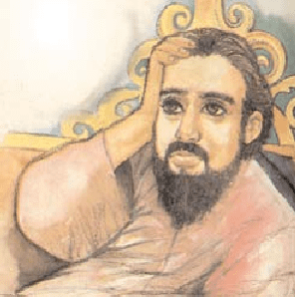

Some time ago, there lived a King. This King should have been contented with his life, given all the riches and luxuries he had. However, this was not the case! The King always found himself wondering why he just never seemed content with his life.

Sure, he had the attention of everyone wherever he went, attended fancy dinners and parties, but somehow, he still felt something was lacking and he couldn’t put his finger on it.

One day, the King had woken up earlier than usual to stroll around his palace. He entered his huge living room and came to a stop when he heard someone happily singing away... following this singing... he saw that one of the servants was singing and had a very contented look on his face.

This fascinated the King and he summoned this man to his chambers. The man entered the King’s chambers as ordered. The King asked why he was so happy?

To this the man replied: “Your Majesty, I am nothing but a servant, but I make enough of a living to keep my wife and children happy. We don’t need too much, a roof over our heads and warm food to fill our tummy. My wife and children are my inspiration; they are content with whatever little I bring home. I am happy because my family is happy.”

Hearing this, the King dismissed the servant and summoned his Personal Assistant to his chambers.

The King related his personal anguish about his feelings and then related the story of the servant to his Personal Assistant, hoping that somehow, he will be able to come up with some reasoning that here was a King who could have anything he wished for at a snap of his fingers and yet was not contented, whereas, his servant, having so little was extremely contented.

The Personal Assistant listened attentively and came to a conclusion. He said, “Your Majesty, I believe that the servant has not been made part of The 99 Club.”

“The 99 Club? And what exactly is that?” the King inquired.

To which the Assistant replied, “Your Majesty, to truly know what The 99 Club is, you will have to do the following... place 99 Gold coins in a bag and leave it at this servant’s doorstep, you will then understand what The 99 Club is.”

That very same evening, the King arranged for 99 Gold coins to be placed in a bag at the servant’s doorstep. Although he was slightly hesitant and he thought he should have put 100 Gold coins into the bag, but since his assistant had advised him to put 99 that is what he did.

The servant was just stepping out of his house when he saw a bag at his doorstep. Wondering about its contents, he took it into his house and opened the bag. When he opened the bag, he let out a great big shout of joy...Gold Coins... so many of them. He could hardly believe it. He called his wife to show her the coins.

He then took the bag to a table and emptied it out and began to count the coins. Doing so,

he realized that there were 99 coins and he thought it was an odd number so he counted again, and again and again only to come to the same conclusion... 99 Gold Coins.



He began to wonder, what could have happened to that last one coin? For no one would leave 99 coins. He began to search his entire house, looked around his backyard for hours, not wanting to lose out on that one coin. Finally, exhausted, he decided that he was going to have to work harder than ever to make up for that one Gold coin to make his entire collection an even 100 Gold Coins.

He got up the next morning, in an extremely horrible mood, shouting at the children and his wife for his delay, not realizing that he had spent most of the night conjuring ways of working hard so that he had enough money to buy himself that gold coin. He went to work as usual - but not in his usual best mood, singing happily - as he grumpily did his daily errands.

Seeing the man’s attitude change so drastically, the King was puzzled. He promptly summoned his assistant to his chambers. The King related his thoughts about the servant and once again, his assistant listened. The King could not believe that the servant who until yesterday had been singing away and was happy and content with his life had taken a sudden change of attitude, even though he should have been happier after receiving the gold coins.

To this the assistant replied “Ah! But your Majesty, the servant has now officially joined The 99 Club.” He explained: “The 99 Club is just a name given to those people who have everything but yet are never contented, therefore they are always working hard and striving for that extra one to round it out to 100!

We have so much to be thankful for and we can live with very little in our lives, but the minute we are given something bigger and better, we want even more!

We are not the same happy contented person we used to be, we want more and more and by wanting more and more we don’t realize the price we pay for it. We lose our sleep, our happiness; we hurt the people around us just as a price to pay for our growing needs and desires. That is what joining The 99 Club is all about.”

Hearing this King decided that from that day onwards, he was going to start appreciating all the little things in life.

Striving for more is always good, but let’s not strive so hard and for so much that we loses all those near and dear to our hearts, we shouldn’t compromise our happiness for moments of luxuries!

# REPENTANCE

A person once heard a pious Muslim say that “For the last thirty years

I am repenting for a sin and I don’t know how Allah will deal with me regarding it?” The listener asked: “What was your sin?”

The pious Muslim said: “I used to have a shop in the Bazaar. One day I heard that the whole Bazaar was burning so I rushed to see my shop. When I reached there I saw that

except my shop all the shops were razed to the ground. I said ‘Al-Hamdo lillah’ (All praise to Allah); but immediately I realized my mistake. How can I call myself a Muslim when I couldn’t feel the loss of my neighbors? That is why I am repenting for that lapse on my part for the last thirty years.”

# THE NEIGHBOR

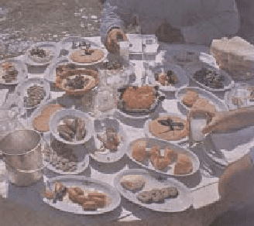

Sayyed Jawad Ameli, a great Mujtahid, was having his dinner when someone knocked at his door. A servant from his master, Ayatullah Sayyed Mehdi Bahrul Uloom, appeared and said: “Your master has sent for you to come immediately. He has just sat down for his dinner but refuses to eat until he sees you.”

There was no time to lose. Sayyed Jawad Ameli left his dinner and rushed to Ayatullah Bahrul Uloom’s residence. Just as he entered, the master looked disapprovingly at him and said: “Sayyed Jawad! You have no fear of Allah!

Don’t you feel ashamed in front of Allah?” This came as a shock to him, as he could not remember doing anything to incur the wrath of his master.

He said: “My master may guide me where I have failed.”

Ayatullah Bahrul Uloom replied: “It is now a week that your neighbor and his family are without wheat and rice. He was trying to buy some dates from a shop on credit but the shopkeeper refused to grant him any more credit. He returned home empty-handed and the family is without a morsel of food.” Sayed Jawad was taken by surprise. “By Allah,” he said, “I have no knowledge about this.”

That is why I am displeased all the more. How can you be unaware of your own neighbor? Seven days of difficulties have passed and you tell me you do not know about it. Well, If you had known and ignored him despite your knowledge, then you would not even he a Muslim, Ayatullah Uloom adjoined. Then he instructed him to take all the dishes of food before him to his neighbor. “Sit with him to eat, so that he does not feel ashamed. And take this sum for his future ration. Place it under his pillow or carpet so that he is not humiliated, and inform me when this work is completed, for not until then shall I eat.” **“That man is not from me who sleeps contentedly while his neighbor sleeps hungry.” Holy Prophet Muhammad (Peace be upon him)**

# A BOX FULL OF KISSES

The story goes back some time ago, a man punished his 3-year-old daughter for wasting a roll of gold wrapping paper. Money was tight and he became infuriated when the child tried to decorate a box to put under the Christmas tree. Nevertheless, the little girl brought the gift to her father the next morning and said, “This is for you, Daddy.”

The man was embarrassed by his earlier over reaction, but his anger flared again when he found out the box was empty. He yelled at her, stating, “Don’t you know, when you give someone a present, there is supposed to be something inside?” The little girl looked up at him with tears in her eyes and cried, “Oh, Daddy, it’s not empty at all. I blew kisses into the box. They’re all for you, Daddy.” The father was crushed. He put his arms around his little girl, and he begged for her forgiveness.

Only a short time later, an accident took the life of the child. It is also told that her father kept that gold box by his bed for many years and, whenever he was discouraged, he would take out an imaginary kiss and remember the love of the child who had put it there.

In a very real sense, each one of us, as humans beings, have been given a gold container filled with unconditional love and kisses... from our children, family members, friends, and God. There is simply no other possession, anyone could hold, more precious than this.

# THE THREE COWS

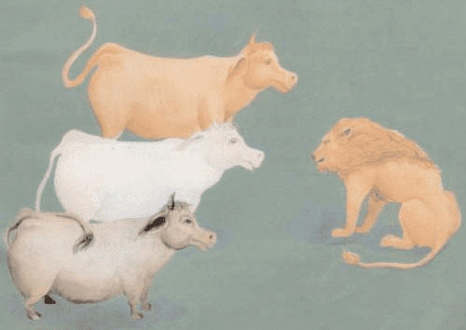

There was a green and fresh pasture, in which three cows lived, a white cow, a black cow and a reddish-brown one. The cows were kind to each other. They were nice to each other. They used to graze in the meadow together. and they used to sleep near each other.

Till it happened one day, the reddish-brown colored lion of the forest happened to pass that way. The lion was unhappy. It was hungry, and was looking for a prey. On catching sight of the cows it became glad, but couldn't attack them, because they were together. So, the lion sat in a corner and waited till the cows would separate from each other.

The cows were together and wouldn’t part away from each other, because they knew that if they were together, no predator could attack them. The lion lay in ambush nearby for two or three days. But the cows continued to remain together, and wouldn’t separate from each other. The lion became unhappy.

A plan occurred to it. It went towards the cows, greeted them and said: “How are you my friends?” Are you fine? I have been remembering you for a long time, but because I am too busy, I can’t come to you and ask about your health.

Today I said to myself: “Anyhow I should come and see you from near and visit you.” The reddish-brown cow said: “Sir, your coming has really pleased us and brightened our pasture.”

The lion said: “I have always remembered you, and have even ordered a better pasture made ready for you.” Reddish-brown cow said: “Sir, you have really obliged us and we are very thankful to you.”

Both the white and the black cows were troubled by what their friend, the reddish-brown cow said, and were grieved at its thoughtlessness. They feared lest it should be deceived.

They said to each other: Which forest has not got a better pasture? Why does the reddish-brown cow believe what the lion says? Doesn’t it know that lions seek other animals only to prey on them?

The reddish-brown cow became more and more a close friend of the lion each day. The black cow and the white cow advised it as much as they could, but with no avail.

One day the lion said to the reddish-brown cow: “You know that the color of our bodies is dark and that the color of the body of the white cow is light, and you also know that the light color is the opposite of the dark color. It would be very good if I eat the white cow, so that there will be no difference among us any longer and that we will be able to live together well.”

The reddish-brown cow accepted the saying of the selfish lion and started talking to the black cow to keep it busy, so that the lion could eat the white cow with more ease. The white cow was left alone and was killed, while the black and the reddish-brown cows were busy with idle talks.

Two or three days passed since the lion had devoured the white cow. The lion, angry and uneasy, was lying in a corner, and the reddish-brown cow was moving around the lion and grazing. The lion called the reddish-brown cow. The cow answered: “Yes sir!”

The lion said: “The color of my body and the color of your body are reddish-brown, and black does not go with our color. It will be very good if I eat the black cow, so that in this forest we all will be of the same color.” The reddish-brown cow accepted and moved away from the black cow.



The lion attacked and devoured the black cow, too. And as for the reddish-brown cow, it was so filled with joy that it didn’t know what to do. It roamed and grazed and said to itself: “It is only me who has the color of the lion...” A few days passed since the black cow had been devoured by the lion. The lion roared and said. “O the reddish-brown cow! Where are you?”

The reddish-brown cow, shaking with fear, went forward and said: “Yes sir!” The lion said: “Today it is your turn, get yourself ready, I am going to eat you.” The reddish-brown cow, with great fear & horror said: “Why sir, I am your friend. I did whatever you said. So why do you want to eat me?”

The lion roared and said: “Friend of a friendless!” How is it possible that a lion makes friendship with a cow? No matter how much the reddish-brown cow begged and entreated, the lion didn’t accept its words. The lion attacked the cow.

The cow said: “Mr. Lion, please allow me to cry out three times before you eat me.” The lion said: “Quickly, quickly!” The reddish-brown cow cried out: “I was eaten the very day the white cow was eaten. I was eaten the very day the black cow was eaten. I was eaten the very day I made. with

you.” The lion devoured the reddish-brown cow very quickly. Then it said to itself: “I have finished my job in this forest. Now I had better go to other forests.” **Divide and rule policy.**

# A WHITE HAS NO SUPERIORITY OVER A BLACK

The following scene took place on a BA flight between Johannesburg and London. A white woman, about 50 years old, was seated next to a black man. Obviously disturbed by this, she called the air Hostess. Madam, what is the matter, the hostess asked you obviously do not see it then?

She responded. You placed me next to a black man. I do not agree to sit next to someone from such a repugnant group. Give me an alternative seat. Be calm please, the hostess replied.

Almost all the places on this flight are taken. I will go to see if another place is available. The Hostess went away and then came back a few minutes later. Madam, just as I thought, there are no other available seats in the economy class. I spoke to the captain and he informed me that there is also no seat in the business class. All the same, we still have one place in the first class.

Before the woman could say anything, the hostess continued. It is not usual for our company to permit someone from the economy class to sit in the first class However, given the circumstances; the captain feels that it would be scandalous to make someone sit next to someone so disgusting. She turned to the black guy, and said. Therefore, Sir, if you would like to, please take your hand luggage because a seat awaits you in the first class. At the moment, the other passengers who were shocked by what they had just witnessed stood up and applauded.

This is a true story against racism, which is not usually told. All mankind is from Adam and Eve; an Arab has no superiority over a non-Arab, nor a non-Arab has any superiority over an Arab; also a white has no superiority over a black, nor does a black have any superiority over white except by piety and good action. Learn that every Muslim is the brother of another Muslim, and that Muslims constitute one brotherhood.

# GHULAMHUSSEIN AND THE GAME OF CHANCE

Ghulamhusein was a popular social figure and a keen host of guests coming to him from distant lands. He lived in Moshi, a beautiful small town at the foot of Mt. Kilimanjaro in Tanzania. He was generous and hospitable to one and all. One of his hobbies during leisure hours particularly on Saturdays and Sundays was to play the game of cards with his friends. For hours they used to get together where they enjoyed the game. It was not with the aim of gambling but rather just for pleasure and pass time.

Once in the midst of a lively game of cards, his servant came to inform him that a guest of his was seriously ill at the guest house and needed his immediate attention. He sent the servant back saying he would come soon. But he was so much engrossed to withdraw from it. So he continued to play with keen interest.

After a while, his servant came again to report that the condition of the guest was deteriorating and needed his urgent attention as there was no one else to attend. But Ghulamhusein was so deeply engrossed in the game that he did not want to be disturbed. As such, again he sent the servant back promising to come soon.

By the time he could be free from the very mind captivating game of cards, the servant came for the third time. But this time he reported that the guest of his a

poor traveler from distant lands had already died. This news gave a shock of his life to Ghulamhusein. It convinced him of the evil and harmful effect of such an indoor game. There and then he vowed never to indulge himself in such a game.

Is this not an eye-opening example of an intoxicating and mentally distracting game of cards, commonly played today either as a pass-time or for gambling purposes? Perhaps it also explains the philosophy behind absolute Islamic forbiddance to play or watch such a game, even without the chance of gaining or losing money. It is meant to be prevention than a cure, lest man is one day tempted to use the game for gambling purpose.

# FINDERS KEEPERS

A wise woman who was traveling in the

**"Abstention from sins is better than**

**seeking help afterward." Imam Ali (AS)**

mountains found a precious stone in a stream. The next day she met another traveler who was hungry, and the wise woman opened her bag to share her food. The hungry



traveler saw the precious stone & asked the woman to give it to him. She did so without hesitation.

The traveler left, rejoicing his good fortune. He knew the stone was worth enough to give him security for a lifetime. But a few days later he came back to return the stone to the wise woman. “I’ve been thinking,” He said, “I know how valuable the stone is, but I give it back in the hope that you can give me something even more precious: Give me what you have within you that enabled you to give me the stone.”

# BANDAGE OF COMPLAINT!

Once a saint saw a man with a bandage tied round his head. “Why have you tied the bandage?” he asked. “Because my head aches,” the man replied. “How old are you?” he demanded. “Thirty,” he replied. “Have you been in pain and anguish the greater part of your life?” he enquired. “No,” the man answered. “For thirty years you have enjoyed good health,” he remarked, “and you never tied the bandage of thankfulness. Now because of this one night head ache, that you have, you tie the bandage of complaint!”

# AN AGED STUDENT

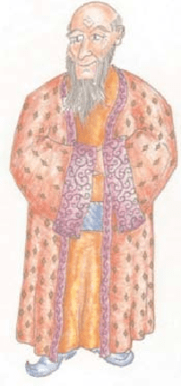

Sikaki was a skilled artist an artisan. With great expertise and interest, he made such a nice and beautiful inkpot that it could be presented to the king. He expected that, appreciating his artistic skill, the king would encourage him as far as possible. So, with countless hopes and thousand of desires, he presented that inkpot to the king. In the beginning the king was very impressed by his artistic skill but afterwards an unpleasant event occurred that caused an extraordinary change in Sikaki’ s life and way of thinking.

When the king was observing the skilled artistry of the beautiful inkpot and Sikaki was lost in the world of thoughts, the people informed that a scholar-literary person or jury is about to enter the court. As soon as the scholar entered, the king got so much absorbed in welcoming and talking to him that he forgot Sikaki and his skilled artistry. This incident caused an adverse and deep effect on the heart of Sikaki.

He realized that now he would not receive the encouragement he had expected and all his desires and hopes are useless now. But Sikaki’s high spirited mind did not allow him to be in peace, so he started thinking as to what should he do. He decided to do what the others have done and go on the same way that the others have gone (uptill now). Therefore, he decided to search for his lost hopes in the world of knowledge, literature and books. Although for a wise man who has passed the days of his young age, it was not easy to study with young children and to start right from the preliminary stage. But he did not have a choice . After all whenever the fish is taken out of water,

it is fresh.

Worse than that, in the beginning he did not find any sort of interest in himself regarding reading and writing. Perhaps spending a long time in artistic works and handicraft was the reason for stagnancy in his scientific and literary talent. But neither his advanced age nor lack of capability, none of these could change his decision. With great enthusiasm and zeal for attaining knowledge, he strictly got busy with his studies, until another incident occurred:

The teacher who was teaching him Shafi’e jurisprudence (fiqh Shafi’e), taught him this lesson: “The teacher believes that the skin of a dog becomes clean (tahir) after tanning.” Sikaki repeated this sentence a lot of times so that at the time of examination he should be able to succeed. But when he was asked to answer this question, he said: “The dog believes that the skin of a teacher becomes clean after tanning.”

The audience upon hearing this answer started laughing. It was clear for everybody that this old man is absolutely incapable of reading and writing. After this incident Sikaki not only left the school , but he left the town and went towards the Jungle. By chance, he reached the

foot of a mountain, where he saw that the water is falling drop by drop from the top and due to the continuous falling of water, a hole had been formed in that hard stone. He reflected for sometime, a good idea crossed his mind like lightning. And he said: “Maybe my heart is not ready to accept (knowledge) but it is not harder than this stone. It is impossible that continuous studying and hard work would be ineffective.”

Therefore, he came back and with hard work, he got busy in the attainment of knowledge. As a result he was reckoned as one of the popular scholars of his time.

**You never be too old to learn something new.**

# WEALTH - LOVE - SUCCESS

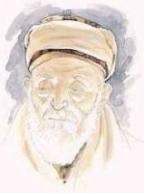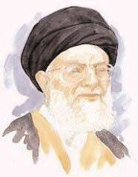

A woman came out of her house and saw 3 old men with long white beards sitting in her front yard. She did not recognize them. She said “I don’t think I know you, but you must be hungry.

Please come in and have something to eat.” “Is the man of the house home?”, they asked. “No,” she replied. “He’s out.”

“Then we cannot come in,” they replied.

In the evening when her husband came home, she told him what had happened.

“Go tell them I am home and invite them in!” The woman went out and invited the men in.

“We do not go into a House together,” they replied. “Why is that?” she asked.

One of the old men explained: “His name is Wealth,” he said pointing to one of his friends, and said pointing to another one, “He is Success, and I am Love.” Then he added, “Now go in and discuss with your husband which one of us you want in your home.”

The woman went in and told her husband what was said. Her husband was overjoyed. “How nice!,” he said. “Since that is the case, let us invite Wealth. Let him come and fill our home with wealth!”

His wife disagreed. “My dear, why don’t we invite Success?”

Their daughter-in-law was listening from the other corner of the house. She jumped in with her own suggestion: “Would it not be better to invite Love? Our home will then be filled with love!”

“Let us heed our daughter-in-law’s advice,” said the husband to his wife. “Go out and invite Love to be our guest.”

The woman went out and asked the 3 old men,

“Which one of you is Love? Please come in and be our guest.”

Love got up and started walking toward the house. The other 2 also got up and followed him. Surprised, the lady asked Wealth and Success: “I only invited Love, Why are you coming in?”

The old men replied together: “If you had invited Wealth or Success, the other two of us would’ve stayed out, but since you invited Love, wherever He goes, we go with him. Wherever there is Love, there is also Wealth and Success!!!”

# LOVE AND TIME

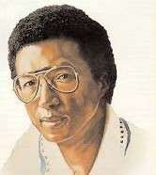

Once upon a time, there was an island where all the feelings lived: Happiness, Sadness, Knowledge, and all of the others, including Love. One day it was announced to the feelings that the island would sink, so all constructed boats and left. Except for Love.

Love was the only one who stayed. Love wanted to hold out until the last possible moment. When the island had almost sunk, Love decided to ask for help.

Richness was passing by Love in a grand boat. Love said, “Richness, can you take me with you?” Richness answered, “No, I can’t. There is a lot of gold and silver in my boat. There is no place here for you.”

Love decided to ask Vanity who was also passing by in a beautiful vessel. “Vanity, please help me!” “I can’t help you, Love. You are all wet and might damage my boat,” Vanity answered.

Sadness was close by so Love asked, “Sadness, let me go with you.” “Oh . . . Love, I am so sad that

I need to be by myself!” Happiness passed by Love, too, but she was so happy that she did not even hear when Love called her.

Suddenly, there was a voice, “Come, Love, I will take you.” It was an elder. So blessed and overjoyed, Love even forgot to ask the elder where they were going. When they arrived at dry land, the elder went his own way. Realizing how much was owed the elder, Love asked Knowledge, another elder, “Who Helped me?”

“It was Time,” Knowledge answered.

“Time?” asked Love. “But why did Time help me?” Knowledge smiled with deep wisdom and answered, “Because only Time is capable of understanding how valuable Love is.”

# ALWAYS THANKFUL TO GOD

Arthur Ashe, the legendary Wimbledon player was dying of AIDS. From world over, he received letters from his fans, one of which conveyed: “Why does GOD have to select you for such a bad disease?”

To this Arthur Ashe replied: The world over 5 Crore children start playing tennis,

50 Lakh learn to play tennis,

5 Lakh learn professional tennis, 50,000 come to the circuit, 5000 reach the grand slam,

50 reach Wimbledon, 4 to semi final,

1. to the finals,

When I was holding a cup I never asked GOD “Why me?”. And today in pain I should not be asking GOD “Why me?”

**Be thankful to GOD for 98% of good things in life.**

# THE MAYONNAISE AND THE COFFEE



When things in your life seem almost too much to handle, when 24 hours in a day are not enough, remember the mayonnaise Jar...and the Coffee...

A professor stood before his philosophy class and had some items in front of him. When the class began, wordlessly, he picked up a very large and empty mayonnaise Jar and proceeded to fill it with golf balls.

He then asked the students if the Jar was full. They agreed that it was. So the professor then picked up a box of pebbles and poured them into the Jar. He shook the Jar lightly. The pebbles rolled into the open areas between the golf balls. He then asked the students again if the Jar was full. They agreed it was.

The professor next picked up a box of sand and poured it into the Jar. Of course, the sand filled up everything else. He asked once more if the Jar was full. The students responded unanimous “yes.”

The professor then produced two cups of Coffee from under the table and poured the entire contents into the Jar, effectively filling the empty space between the sand. The students laughed.

“Now,” said the professor, as the laughter subsided, “I want you to recognize that this Jar represents your life. The golf balls are the important things, your God, family, your children, your health, your friends, and your favorite passions things that if everything else was lost and only they remained, your life would still be full.” The pebbles are the other things that matter like your job, your house, and your car. The sand is everything else the small stuff.

“If you put the sand into the Jar first,” he continued, “there is no room for the pebbles or the golf balls.” The same goes for life. If you spend all your time and energy on the small stuff, you will never have room for the things that are important. Pay attention to the things that are critical to your happiness. Play with your children. Take care of the golf balls first, the things that really matter. Set your priorities. The rest is just sand.

One of the students raised her hand and inquired what the Coffee represented. The professor smiled. “I’m glad you asked. It just goes to show you that no matter how full your life may seem, there’s always room for a couple of cups of Coffee with a friends.”

# THE BAR

A tale is told about a small town that had historically been “dry,” (no alcohol sold) but then a local businessman decided to build a tavern. A group of Christians from a local church were concerned and planned an all-night prayer meeting to ask God to intervene.

It just so happened that shortly thereafter lightning struck the bar and it burned to the ground. The owner of the bar sued the church, claiming that the prayers of the congregation were responsible, but the church hired a lawyer to argue in court that they were not responsible.

The presiding judge, after his initial review of the case, stated that “No matter how this case comes out, one thing is clear. The tavern owner believes in prayer and the Christians do not.”

# LESSONS ON LIFE

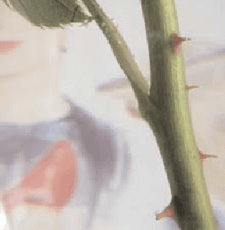

There was a man who had four sons. He wanted his sons to learn not to judge things too quickly. So he sent them each on a quest, in turn, to go and look at a pear tree that was a great distance away. The first son went in the winter, the second in the spring, the third in summer, and the youngest son in the fall.

When they had all gone and come back, he called them together to describe what they had seen. The first son said that the tree was ugly, bent, and twisted. The second son said no it was covered with green

buds and full of promise. The third son disagreed; he said it was laden with blossoms that smelled so sweet and looked so beautiful, it was the most graceful thing he had ever seen. The last son disagreed with all of them; he said it was ripe and drooping with fruit, full of life and fulfillment.

The man then explained to his sons that they were all right, because they had each seen but only one season in the tree’s life. He told them that you cannot judge a tree, or a person, by only one season, and that the essence of who they are and the pleasure, joy, and love that come from that life can only be measured at the end, when all the seasons are up.

If you give up when it’s winter, you will miss the promise of your spring, the beauty of your summer, fulfillment of your fall. Don’t let the pain of one season destroy the joy of all the rest. Don’t judge life by one difficult season. Persevere through the difficult patches and better times are sure to come some time or later.

# THE ROSE WITHIN

A certain man planted a rose and watered it faithfully and before it blossomed, he examined it. He saw the bud that would soon blossom, but noticed thorns upon the stem and he thought, “How can any beautiful flower come from a plant burdened with so many sharp thorns?” Saddened by this thought, he neglected to water the rose, and just before it was ready to bloom... it died.

So it is with many people. Within every soul there is a rose. The good qualities planted in us at birth, grow amid the thorns of our faults. Many of us look at ourselves and see only the thorns, the defects.

We despair, thinking that nothing good can possibly come from us. We neglect to water the good within us, and eventually it dies. We never realize our potential.

Some people do not see the rose within themselves; someone else must show it to them. One of the greatest gifts a person can possess is to be able to reach past the thorns of another, and find the rose within them.

This is one of the characteristic of love... to look at a person, know their true faults and accepting that person into your life... all the while recognizing the nobility in their soul. Help others to realize they can overcome their faults. If we show them the “rose” within themselves, they will conquer their thorns. Only then will they blossom many times over.

**The most favorable friend to me is that who shows me my flaws. Imam Sadiq (AS)**

# PUT THE GLASS DOWN!



A professor began his class by holding up a glass with some water in it. He held it up for all to see and asked the students, “How much do you think this glass weighs?”

‘50 gms!’.... ‘100 gms!’...... ‘125 gms’ the students answered.

“I really don’t know unless I weigh it,” said the professor, “but, my question is: What would happen if I held it up like this for a few minutes?” “Nothing” the students said.

“Ok! What would happen if I held it up like this for an hour?” the professor asked. “Your arm would begin to ache,” said one of the students.

“You’re right, now what would happen if I held it for a day?”

“Your arm could go numb, you might have severe muscle stress and paralysis and have to go to hospital for sure!” ventured another student; and all the students laughed.

“Very good. But during all this, did the weight of the glass change?” asked the professor. “No” the students said.

“Then what caused the arm ache and the muscle stress?” The students were puzzled. “Put the glass down!” said one of the students.

“Exactly!” said the professor. “Life’s problems are something like this. Hold it for a few minutes in your head and they seem okay. Think of them for a long time and they begin to ache. Hold it even longer and they begin to paralyze you. You will not be able to do anything.”

“It’s important to think of the challenges (problems) in your life, but EVEN MORE IMPORTANT is to have trust in Allah (swt) and to ‘put them down’ at the end of every day before you go to sleep.

That way, you are not stressed, you wake up every day fresh and strong and can handle any issue, any challenge that comes your way!”

So, as it becomes time for you to leave office today, Remember friend to “PUT THE GLASS DOWN TODAY” and have tranquility by putting trust in Almighty Allah (swt).

Holy Quran (48:4) says: “He it is who sent down tranquility into the hearts of the believers that they might have more faith added to their faith.” Tranquility is sign of strong faith while worries and stress is sign of weak faith. Tell to your mind every day before you go to sleep: “YAA AYYATUHAN NAFSUL MUTMAINNAH, IRJI’II ILAA RABBIKI RADHIYATAN MARDHIYYAH, FADKHULII FII IBAADII WADKHULII JANNATII”. (Al-Fajr 89:27-30)

“O soul that is at rest satisfied. Return to your Lord well-pleased (with Him), well-pleasing (Him). So, enter among My servants, and enter into my Paradise.”

**By worrying so much, do not turn your life to hell. Good luck.**

# MAY I NEVER GET TOO BUSY IN MY OWN AFFAIRS!



It was a bitter, cold evening. The old man’s beard was glazed by winter’s frost while he waited for a ride across the river. The wait seemed endless. His body became numb and stiff from the frigid north wind. He heard the faint, steady rhythm of approaching hooves galloping along the frozen path.

Anxiously, he watched as several horsemen rounded the bend. He let the first one pass by without an effort to get his attention. Then another passed by... and another.

Finally, the last rider neared the spot where the old man sat like a snow statue.

As this one drew near, the old man caught the rider’s eye and said, “Sir, would you mind giving an old man a ride to the other side?

There doesn’t appear to be a passageway by foot.”

Reining his horse, the rider replied, “Sure thing. Hop aboard.”

Seeing the old man was unable to lift his half-frozen body from the ground, the horseman dismounted and helped the old man onto the horse. The horseman took the old man not just across the river, but to his destination, which was just a few miles away.

As they neared the tiny but cozy cottage, the horseman’s curiosity caused him to inquire, “Sir, I notice that you let several other riders pass by without making an effort to secure a ride. Then I came up and you immediately asked me for a ride. I’m curious why, on such a bitter winter night; you would wait and ask the last rider. What if I had refused and left you there?”

The old man lowered himself slowly down from the horse, looked the rider straight in the eyes, and replied, “I’ve been around here for some time. I reckon I know people pretty good.”

The old-timer continued, “I looked into the eyes of the other riders and immediately saw there was no concern for my situation. It would have been useless even to ask them for a ride. But when I looked into your eyes, kindness and compassion were evident. I knew, then and there, that your gentle spirit would welcome the opportunity to give me assistance in my time of need.”

Those heartwarming comments touched the horseman deeply.

“I’m most grateful for what you have said,” he told the old man. “May I never get too busy in my own affairs that I fail to respond to the needs of others with kindness and compassion.”

Ya Allah, Make me among those about whom the Holy Quran (Hashr 59:9) has said: “And they give them preference over their own selves even though they are in need.”

# DON’T WE ALL

I was parked in front of the mall wiping off my car. I had just come from the car wash and was waiting for my wife to get out of work. Coming my way from across the parking lot was what society would consider a bum. From the looks of him, he had no car, no home, no clean clothes, and no money.

There are times when you feel generous but there are other times that you just don’t want to be bothered. This was one of those “don’t want to be bothered times.”



“I hope he doesn’t ask me for any money,” I thought. He didn’t.

He came and sat on the curb in front of the bus stop but he didn’t look like he could have enough money to even ride the bus. After a few minutes he spoke. “That’s a very pretty car,” he said.

He was ragged but he had an air of dignity around

him. His scraggly blond beard keeps more than his face warm. I said, “Thanks,” and continued wiping off my car.

He sat there quietly as I worked. The expected plea for money never came.

As the silence between us widened something inside said, “Ask him if he needs any help.” I was sure that he would say “yes” but I held true to the inner voice.

“Do you need any help?” I asked.

He answered in three simple but profound words that I shall never forget. We often look for wisdom in great men and women. We expect it from those of higher learning and accomplishments.

I expected nothing but an outstretched grimy hand. He spoke the three words that shook me. “Don’t we all?” he said.

I was feeling high and mighty, successful and important, above a bum in the street, until those three words hit me like a twelve gauge shotgun. Don’t we all?

I needed help. Maybe not for bus fare or a place to sleep, but I needed help. I reached in my wallet and gave him not only enough for bus fare, but enough to get a warm meal and shelter for the day. Those three little words still ring true. No matter how much you have, no matter how much you have accomplished, you need help too. No matter how little you have, no matter how loaded you are with problems, even without money or a place to sleep, you can give help.

Even if it’s just a compliment, you can give that. You never know when you may see someone that appears to have it all. They are waiting on you to give them what they don’t have. A different perspective on life, a glimpse at something beautiful, a respite from daily chaos, that only you through a torn world can see.

Maybe the man was just a homeless stranger wandering the streets. Maybe he was more than that. maybe he was sent by a power that is great and wise, to messenger to a soul too comfortable in themselves. Maybe God looked down, called an Angel, dressed him like a bum, and then said,

“Go messenger to that man cleaning the car, that man needs help.” Don’t we all?

**“.....Even a smile can be charity. ” Holy Prophet Muhammad (Peace be upon him)**

# THE STRANGER IN THE GARDEN

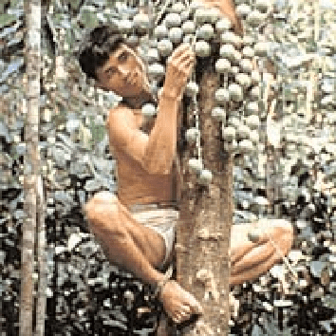

Once upon a time there was a man who had a big garden. He had planted many fruit trees and cared for them till they bear fruits. Now he wanted to pick up the fruits and sell them to make money for his family.

One fine day while picking fruits with his son, the man saw a stranger sitting on the branch of a tree and picking the fruits. This man become angry and shouted, “Hey you! What are you doing on my tree? Aren’t you ashamed of stealing fruits in the day time?” The stranger on the branch just looked at the gardener but didn’t reply, and continued picking the fruits. The gardener was very angry and shouted again, “For a whole year

I have taken care of these trees, you have no right to take the fruits without my permission so come down at once!”

The stranger on the tree answered, “Why should I come down? This is the garden of God and I am the servant of God, so I have the right to pick these fruits and you should not interfere between the work of God and his servant.” The gardener was very surprised at this answer and thought of a plan. He called his son and said, “go bring a rope and get this man down from the tree.” His son brought the rope and the gardener ordered him to tie the stranger to the tree. The gardener then took a stick and started to beat the stranger. The stranger began to scream. “Why are you beating me? You have no right to do this.”

The gardener paid no attention and continued beating him. The stranger screamed, “Don’t you fear God, you are beating an innocent man? The gardener answered, “Why should I fear? This wood in my hand belongs to God and I am too the servant of God, so I have nothing to fear, and you shouldn’t interfere with the work of God and his servant.” The stranger hesitated and then spoke, “Wait don’t beat me, I am sorry for taking the fruits. This is your garden and I should seek your permission before taking the fruits. So, please forgive and set me free.”

The gardener smiled and said, “Since you have now realized your mistake, I will forgive you but remember that God has given all his servants brains so every person’s deeds are in his own hands.” Then the gardener untied him and let him go free.

# TO TELL THE TRUTH

“Who did this?” asked my teacher. Thirty children tried to think about not only what they had done, but also what our teacher may have found out. “Who did this?” asked my teacher once more. She wasn’t really asking, she was demanding an answer. She seldom became angry, but she was this time. She held up a piece of broken glass and asked, “Who broke this window?”

“Oh, oh,” I thought. I was the one who broke the window. I had not done it intentionally. It was caused by an errant throw of a baseball. I was working on my knuckleball. It needed more work. Why did it have to be me? It wasn’t really my fault. If I admitted guilt, I would be in a lot of trouble. How would I be able to pay for a big window like that? I didn’t even get an allowance. “My father is going to have a fit,” I thought. I didn’t want to raise my hand, but some force much stronger than I was pulled it skyward. I told the truth. “I did it.” I said no more. It was hard enough saying what I had.

My teacher went to one of our library shelves and took down a book. She then began walking towards my desk. I had never seen my teacher to strike a student, but I feared she was going to start with me and she was going to use a book for the swatting.

**"Do not be like persons on whom advice has no effect; they require punishments to improve them.**

**A sensible man acquires guidance through advice, while brutes and beasts always improve through punishments." Imam Ali (AS)**

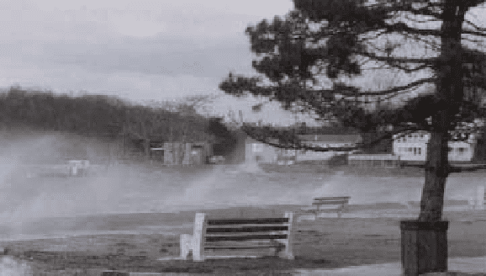

“I know how you like birds,” she said as she stood looking down at my guilt-ridden face. “Here is that field guide about birds that you are constantly checking out. It is yours. It’s time we got a new one for the school anyway. The book is yours and you will not be punished as long as you remember that I am not rewarding you for your misdeed, I am rewarding you for your truthfulness.”

# WHEN THE WINDS BLOW

Years ago a farmer owned land along the Atlantic seacoast. He constantly advertised for hired hands. Most people were reluctant to work on farms along the Atlantic. They dreaded the awful storms that raged across the ocean, wreaking havoc on the buildings and crops. As the farmer interviewed applicants for the job, he received a steady stream of refusals.

Finally, a short, thin man, well past middle age, approached the farmer. “Are you a good farmhand?” the farmer asked him. “Well, I can sleep when the wind blows,” answered the man.

Although puzzled by this answer, the farmer, desperate for help, hired him. The little man worked well around the farm, busy from dawn to dusk, and the farmer felt satisfied with the man's work.

Then one night the wind howled loudly in from offshore. Jumping out of bed, the farmer grabbed a lantern and rushed next door to the hired hand’s sleeping quarters. He shook the little man and yelled, “Get up! A storm is coming! Tie things down before they blow away!”

The little man rolled over in bed and said firmly, “No sir. I told you, I can sleep when the wind blows.”

Enraged by the response, the farmer was tempted to fire him on the spot. Instead, he hurried outside to prepare for the storm. To his amazement, he discovered that all of the haystacks had been covered with tarpaulins. The cows were in the barn, the chickens were in the coops, and the doors

were barred. The shutters were tightly secured. Everything was tied down. Nothing could blow away.

The farmer then understood what his hired hand meant, so he returned to his bed to also sleep while the wind blew.

When you’re prepared, spiritually, mentally, and physically, you have nothing to fear. Can you sleep when the wind blows through your life? The hired hand in the story was able to sleep because he had secured the farm against the storm.

**We with faith secure ourselves against the storms of life by putting our trust in the God, Our Prophet (SAW) and his Ahlul Byat (AS), We don’t need to understand, and we just need to hold His hand to be secure in the midst of the storms.**

# THE ROPE

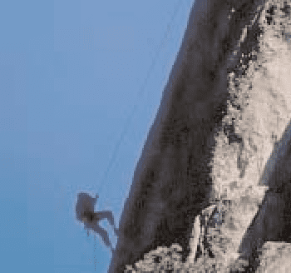

The night fell heavy in the heights of the mountains and the man could not see anything. All was black. Zero visibility, and the moon and the stars were covered by the clouds. As he was climbing only a few feet away from the top of the mountain, he slipped and fell in to the air, falling at great speed. He could only see black spots as he went down, and the terrible sensation of being sucked by gravity.

He kept falling, and in the moments of great fear, it came to his mind all the good and bad episodes of his life. He was thinking now about how close death was getting, when all of a sudden he felt the rope tied to his waist pull him very hard. His body was hanging in the air.

Only the rope was holding him and in that moment of stillness he had no other choice other to scream: “Help me God.”

All of a sudden a deep voice coming from the sky answered, “What do you want me to do?” “Save me God.”

“Do you really think I can save you?” “Of course I believe You can.”

“Then cut the rope tied to your waist.”

There was a moment of silence and the man decided to hold on to the rope with all his strength. The rescue team tells that the next day a climber was found dead and frozen, his body hanging from a rope. His hands holding tight to it. Only one foot away from the ground.

**And We? How attached we are to our rope will we let go??? Don’t ever doubt about the words of God. We should never say that He has forgotten us or abandoned us.**

# THE SHIP

A voyaging ship was wrecked during a storm at sea and only two of the men on it were able to swim to a small, desert like island.

The two survivors, not knowing what else to do, agreed that they had no other recourse but to pray to God. However, to find out whose prayer was more powerful, they agreed to divide the territory between them and stay on opposite sides of the island.

The first thing they prayed for was food. The next morning, the first man saw a fruit-bearing tree on his side of the land, and he was able to eat its fruit. The other man’s parcel of land remained barren.

After a week, the first man was lonely and he decided to pray for a wife. The next day, another ship was wrecked, and the only survivor was a woman who swam to his side of the land. On the other side of the island, there was nothing.

Soon the first man prayed for a house, clothes, more food. The next day, like magic, all of these

were given to him. However, the second man still had nothing.



Finally, the first man prayed for a ship, so that he and his wife could leave the island. In the morning, he found a ship docked at his side of the island. The first man boarded the ship with his wife and decided to leave the second man on the island.

He considered the other man unworthy to receive God’s blessings, since none of his prayers had been answered.

As the ship was about to leave, the first man heard a voice from heaven booming, “Why are you leaving your companion on the island?”

“My blessings are mine alone, since I was the one who prayed for them,” the first man answered. “His prayers were all unanswered and so he does not deserve anything.”

“You are mistaken!” the voice rebuked him. “He had only one prayer, which I answered. If not for that, you would not have received any of my blessings.”

“Tell me,” the first man asked the voice, “What did he pray for that I should owe him anything?” “He prayed that all your prayers be answered.”

**For all we know, our blessings are not the fruits of our prayers alone, but those of another praying for us.**

# THE CLEVER KING!

There was a country long time ago where the people would change a king every year. The person who would become the king had to agree to a contract that he would be sent to an island after his one year of being a king.

One king finished his term and it was time for him to go to the island and live there. The people dressed him up in expensive clothes and put him on an elephant and took him around the cities to say goodbye to all the people. This was the moment of sadness for all the kings who ruled for one year. After saying farewell, the people took the king with a boat to remote island and left him there.

On their way back, they discovered a ship that had sunk just recently. They saw a young man who survived by holding on to a floating piece of wood. As they needed a new king, they picked up the young man and took him to their country. They requested him to be a king for a year. First he refused but later he agreed to be a king. People told him about all the rules and regulations and that how he will be sent to an island after one year.

After three days of being a king, he asked the ministers if they could show him the island where all the other kings were sent. They agreed and took him to the island. The island was covered with thick Jungles and sounds of vicious animals were heard coming out of them. The king went little bit inside to check. Soon he discovered the dead bodies of all the past kings. He understood that as soon as they were left in the island, the animals came and killed them.

The king went back to the country and collected 100 strong workers. He took them to the island and instructed them to clean the Jungle, remove all the deadly animals & cut down all excess trees.

He would visit the island every month to see how the work was progressing. In the first month, all the animals were removed and many trees were cut down. In the second month, the whole island was cleaned out. The king then told the workers to plant gardens in various parts of the island.



He also took with himself useful animals like chickens, ducks, birds, goats, cows etc. In the third month, he ordered the workers to build big houses and docking stations for ships. Over the months, the island turned into a beautiful place.

The young king would wear simple clothes and spend very little from his earnings as a king. He sent all the earnings to the island for storage. When nine months passed like this, the king called the ministers and told them: “I know that I have to go the island after one year, but I would like to go there right now.” But the ministers didn’t agree to this and said that he has to wait for another 3 months to complete the year.

1. months passed and now it was a full year. The people dressed up the young king and put him on an elephant to take him around the country to say goodbye to others. However, this king is

unusually happy to leave the kingdom.

People asked him, “All the other kings would cry at this moment and why are you laughing?”

He replied, “Don’t you know what the wise people say? They say that when you came to this world as a baby, you were crying and everyone was smiling. Live such a life that when you are die, you will be smiling and everyone around you will be crying. I have lived that life. While all the other kings were lost into the luxuries of the kingdom, I always thought about the future and planned for it. I turned the deadly island into a beautiful abode for me where I can stay peacefully.”

The moral lesson from this story is about how we should live our life. The life of this world is to prepare for the life hereafter. In this life, we shouldn’t get lost into the deceiving and attractive things of this world and forget about what is to come in the afterlife. Rather, even if we are kings, we should live a simple life like our beloved Prophet Muhammad (SAW) and save all our enjoyments for the hereafter. May Allah make it easy for us all. Amin.

Holy Quran (31:34) says: Verily the knowledge of the Hour is with Allah (alone). It is He Who sends down rain, and He Who knows what is in the wombs. Nor does any one know what it is that he will earn on the morrow: Nor does any one know in what land he is to die. Verily with Allah is full knowledge and He is acquainted (with all things).

Holy Quran (59:18) urges us to prepare for tomorrow: O ye who believe! Fear Allah, and let every soul look to what (provision) He has sent forth for the morrow. Yea, fear Allah: for Allah is

well-acquainted with (all) that ye do.

**Some body asked Imam Hassan (AS),**

**Why are we reluctant to die, why don’t we like death?**

**“Because,” replied the Imam Hassan (AS),**

**“You ruined your next world and developed this one; naturally, you do not like to be transferred from flourishing to decline.”**

# THE ILLUSION OF REFLECTION



Once there was a king who had presented his daughter, the princess, with a beautiful diamond necklace. The necklace was stolen and his people in the kingdom searched everywhere but could not find it. Some said a bird might have stolen it. The king then asked them all to search for it and put a reward for $50,000 for anyone who found it.

One day a clerk was walking home along a river next to an industrial area. This river was completely polluted, filthy and smelly. As he was walking, the clerk saw a shimmering in the river and when he looked, he saw the diamond necklace. He decided to try and catch it so that he could get the $50,000 reward. He put his hand in the filthy, dirty river and grabbed at the necklace, but some how missed it and didn't catch it. He took his hand out and looked again and the necklace was still there. He tried again, this time he walked in the river and dirtied his pants in the filthy river and put his whole arm in to catch the necklace. But strangely, he still missed the necklace!

He came out and started walking away, feeling depressed.

Then again he saw the necklace, right there. This time he was determined to get it, no matter what. He decided to plunge into the river, although it was a disgusting thing to do as the river was polluted, and his whole body would become filthy. He plunged in, and searched everywhere for the necklace and yet he failed. This time he was really bewildered and came out feeling very depressed that he could not get the necklace that would get him $50,000.

Just then a saint who was walking by, saw him, and asked him what was the matter. The clerk didn't want to share the secret with the saint, thinking the saint might take the necklace for himself, so he refused to tell the saint anything. But the saint could see this man was troubled and being compassionate, again asked the clerk to tell him the problem and promised that he would not tell anyone about it. The clerk mustered some courage and decided to put some faith in the saint. He told the saint about the necklace and how he tried and tried to catch it, but kept failing. The saint then told him that perhaps he should try looking upward, toward the branches of the tree, instead of in the filthy river. The clerk looked up and true enough, the necklace was dangling on the branch of a tree. He had been trying to capture a mere reflection of the real necklace all this time.

Material happiness is just like the filthy, polluted river; because it is a mere reflection of the TRUE happiness in the spiritual world.

We can never achieve the happiness we are looking for no matter how hard we endeavor in material life. Instead we should look upwards, toward God, who is the source of real happiness, and stop chasing after the reflection of this happiness in the material world. This spiritual happiness is the only thing that can satisfy us completely.

**“Happy is the man who always kept the afterlife in his view, who remembers**

**the Day of Reckoning through his deeds, who led a contented life and who was happy with the lot that Allah hath destined for him.” Imam Ali (AS)**

# BUILDING YOUR HOUSE

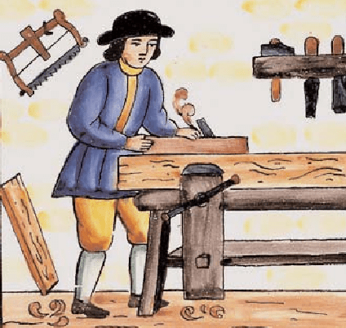

An elderly carpenter was ready to retire. He told his employer-contractor of his plans to leave the house-building business to live a more leisurely life with his wife and enjoy his extended family. He would miss the paycheck each week, but he wanted to retire. They could get by.

The contractor was sorry to see his good worker go & asked if he could build just one more house as a personal favor. The carpenter said yes, but over time it was easy to see that his heart was not in his work. He resorted to shoddy workmanship and used inferior materials. It was an unfortunate way to end a dedicated career.

When the carpenter finished his work, his employer came to inspect the house. Then he handed the front-door key to the carpenter and said, "This is your house... my gift to you."

The carpenter was shocked!

What a shame! If he had only known he was building his own house, he would have done it all so differently.

So it is with us. We build our lives, a day at a time, often putting less than our best into the building. Then, with a shock, we realize we have to live in the house we have built.

If we could do it over, we would do it much differently.

But, you cannot go back. You are the carpenter, and every day you hammer a nail, place a board, or erect a wall. Someone once said, “Life is a do-it-yourself project.” Your attitude, and the choices you make today, helps build the “house” you will live in tomorrow. Therefore, build wisely!

# SAND AND STONE

A story tells that two friends were walking through the desert. During some point of the journey they had an argument, and one friend slapped the other one in the face. The one who got slapped was hurt, but without saying anything, wrote in the sand: “TODAY MY BEST FRIEND SLAPPED ME IN THE FACE.”

They kept on walking until they found an oasis, where they decided to take a bath. The one, who had been slapped, got stuck in the mire and started drowning, but the friend saved him. After the friend recovered from the near drowning, he wrote on a stone: “TODAY MY BEST FRIEND SAVED MY LIFE.”

The friend who had slapped and saved his best friend asked him, “After I hurt you, you wrote in the sand and now, you write on a stone, why?”

The other friend replied: “When someone hurts us, we should write it down in sand where winds of forgiveness can erase it away. But, when someone does something good for us, we must engrave it in stone where no wind can ever erase it.”

**Learn to write your hurts in the sand, and to carve your benefits in stone.**

# A TEACHER’S PROTEST!



There was no timetable nor a room designated for PRAYERS in the School. The School was ‘secular,’ hence prayers were not supposed to be allowed.

After being interviewed and accepted by the school administration, the eager teaching prospect said in protest: “Let me see if I’ve got this right.” You want me to go into that room with all those kids and fill their every waking moment with a love for learning. And I’m supposed to instill a sense of pride in their ethnicity, modify their disruptive behavior, observe them for signs of abuse and even censor their T-shirt messages and dress habits.

You want me to wage a war on drugs and sexually transmitted diseases, check their backpacks for weapons of mass destruction, and raise their self-esteem.

You want me to teach them firm belief in God, patriotism, good citizenship, sportsmanship, and fair play, how and where to register to vote, how to balance a checkbook, & how to apply for a job.

I am to check their heads for lice, maintain a safe environment, recognize signs of antisocial behavior, offer advice, write letters of recommendation for student employment and scholarships, and encourage respect for their elders and future employers.

And I am to communicate regularly with the parents by letter, telephone, newsletter, & report card.

All of this I am to do with just a piece of chalk, a blackboard, a few books, a bulletin board, and a big smile AND on a starting salary that qualifies my family for food stamps!

You want me to do all of this, and you expect me NOT TO PRAY.

You expect me not to pray when Holy Quran (Baqarah 2:45) says: “Nay, seek (Allah’s) help with patient perseverance and PRAYER: It is indeed hard, except to those who bring a lowly spirit.”

“O my Lord! Make me and my children among those who establish prayers.” (Ibrahim: 40) “Indeed it is the Prayers, which helps to refrain from indecent acts and evils.” (Ankabut: 45)

You want me to do all of this and you expect me not to pray when SUCCESS of every one depends on Prayers. Holy Quran (Al-Mu’minuun: 9) says that successful believers are: “. those who are

punctual in their prayers.”

Dear sir, since I am sure that I will not be able to fulfill your expectations, nor I will be successful in my career WITHOUT prayers, “I resign willingly from the post.”

The Administrator looked down for a while then suddenly declared: “Young man, go ahead with your job. You have taught me a very important lesson today: Without prayers and help from God, no work is a success. We shall make special arrangements for prayers from today.”

# DO NOT DO EVIL TO ANYONE



There was a man in Isfahan who used to beat his wife but unfortunately she succumbed to his beating though he had not intended to kill her. But when she was dead he became fearful of her relatives. In a state of anxiety he came out of his house and met an acquaintance to whom he posed his problem.

The friend told him to invite a young man to his house and behead him and put the severed head next to the wife’s corpse. Then he would tell the wife’s relatives that he had found them together in bed and was unable to control his ire. And slew them both. The man liked the idea and sat at the doorway in anticipation of

a young man. After sometime a handsome youth passed by his house. He invited him inside and beheaded him.

Then he summoned the wife’s relatives and told them the fictitious story. They were satisfied but the person who had devised this plan had a teenage son who did not reach home that day. The man was worried and when the son failed to turn up he came to the house of the one whom he had offered evil advice and asked him if he carried out the plan suggested by him. Yes, said he and took him near the dead bodies. He was shocked when he saw that the youth he had killed was his own son. His evil advice caused the death of his own son.

**The moral of this story is that one who digs a pit for others falls into it himself.**

**History is replete with such incidents.**

According to Tafserul Mizan the following saying was common among the Arabs: One who digs a hole for his brother; Allah throws him headlong into it. A similar proverb is present in Persian also: Do not do evil to anyone the sane evil will turn towards you.

Reference: Greater Sins Vol. 3 (English) by Ayatullah Dastagaub Shirazi

# PUPPIES FOR SALE

A farmer had some puppies he needed to sell. He painted a sign advertising the pups and set about nailing it to a post on the edge of his yard. As he was driving the last nail into the post, he felt a tug on his overalls. He looked down into the Eyes of a little boy.

“Mister,” he said, “I want to buy one of your puppies.”

“Well,” said the farmer, as he rubbed the sweat off the back of his neck, “these puppies come from fine parents and cost a good deal of money.”

The boy dropped his head for a moment. Then reaching deep into his pocket, he pulled out a handful of change and held it up to the farmer. “I’ve got thirty-nine cents. Is that enough to take a look?” “Sure,” said the farmer.

And with that he let out a whistle, “Here Dolly!” he called.

Out from the doghouse and down the ramp ran Dolly followed by four little balls of fur. The little boy pressed his face against the chain link fence. His eyes danced with delight.

As the dogs made their way to the fence, the little boy noticed something else stirring inside the doghouse. Slowly another little ball appeared; this One noticeably smaller. Down the ramp it slid. Then in a somewhat awkward manner the little pup began hobbling toward the others, doing its best to catch up....



“I want that one,” the little boy said, pointing to the runt.

The farmer knelt down at the boy's side and said, “Son, you don’t want that puppy. He will never be able to run and play with you like these other dogs would.”

With that the little boy stepped back from the fence, reached down, and began rolling up one leg of his trousers. In doing so he revealed a steel brace running down both sides of his leg attaching itself to a specially made

shoe. Looking back up at the farmer, he said, “You see sir, I don’t run too well myself, and he will need someone who understands.”

**The world is full of people who need someone who understands.**

# OFFFICE BOY

A jobless man applied for the position of “office boy” at a very big firm.

The HR manager interviewed him, then a test: clean the floor. “You are hired” he said, give me your email address, and I’ll send you the application to fill, as well as when you will start.

The man replied “I don’t have a computer, neither an email.”

I’m sorry, said the HR manager, if you don’t have an email that means you do not exist. And who doesn’t exist, cannot have the job. The man left with no hope at all. He didn’t know what to do, with only $10 US in his pocket.

He then decided to go to the supermarket and buy a 10 KG tomato crate. He then sold the tomatoes in a door to door round. In less than two hours, he succeeded to double his capital. He repeated the operation 3 times, and returned home with $60 US. The man realized that he can survive by this way, and started to go everyday earlier, and return late. Thus, his money doubles or triples every day. Shortly later, he bought a cart, then a truck, and then he had his own fleet of delivery vehicles.

5 years later, the man is one of the biggest food retailers in the US. He started to plan his family’s future, and decided to have a life insurance.

He called an insurance broker, and chooses a protection plan. When the conversation was concluded, the broker asked him his email. The man replied: “I don’t have an email.” The broker replied curiously, you don’t have an email, and yet have succeeded to build an

empire. Do you imagine what you could have been if you had an email? The man thought for a while, and replied: an office boy!

**The moral of this story:**

1: Internet is not the solution to your life.

2: If you don’t have internet and you work hard you can be a millionaire.

3: If you received this message by email, you are closer to be an office boy, rather than a MILLIONAIRE.

# ONE BEDROOM FLAT

As the dream of most parents I had acquired a MBBS degree and passed PLAB to enter UK, the land of braves and opportunity. When I arrived in the UK, it was as if a dream had come true. Here at last I was in the place where I wanted to be. I decided I would be staying in this country for about Five years (maximum Permit Free Period) in which time I would have earned enough money to settle down in India.

My father was a government employee and after his retirement, the only asset he could acquire was a decent one bedroom flat. I wanted to do some thing more than him. I started feeling homesick and lonely as the time passed. I used to call home and speak to my parents every week using cheap international phone cards.

Two years passed, two years of Burgers at McDonald’s and chicken legs in KFC and discos and 2 years watching the foreign exchange rate getting happy whenever the Rupee value went down.

Finally I decided to get married. Told my parents that I have only 10 days of holidays and everything must be done within these 10 days. I got my ticket booked in the cheapest flight. Was jubilant as I was actually enjoying shopping for gifts for all my relatives and friends back home.

If I miss anyone then there will be talks. After reaching home I spent home one week going through all the photographs of girls and as the time was getting shorter I was forced to select one candidate. In-laws told me, to my surprise, that I would have to get married in 2-3 days, as I will not get anymore holidays soon and they cannot wait for long.

After the marriage, it was time to return to UK, after giving some money to my parents and telling the neighbors to look after them, we (I was lucky and managed to get the visa of my wife early) returned to UK.

My wife enjoyed this country for about two months and then she started feeling lonely. The frequency of calling India increased to twice in a week sometimes 3 times a week as she also has to call her parents. Our savings started diminishing. After two more years we started to have kids.

Two lovely kids, a boy and a girl, were gifted to us by the almighty. Every time I spoke to my parents, they asked me to come to India so that they can see their grand-children. Every year I decide to go to India.

But part work, part monetary conditions prevented it. Years went by and visiting India was a distant dream. Then suddenly one day I got a message that my parents were seriously sick. I tried but I couldn’t get any holidays and was stuck up in the procedures and thus could not go to India. The next message I got was my parents were passed away and as there was no one to do the last rites the society members had done whatever they could. I was depressed. My parents passed away without seeing their grand children.

After couple more years passed away, much to my children’s dislike (by now nearly cocos) and my wife’s joy we returned to India to settle down. I started to look for a suitable property, but to my dismay my savings were short and the property prices had gone up during all these years. I had to return to the UK. My wife refused to come back with me and my children refused to stay in India. My 2 children and I returned to UK after promising my wife I would be back for good after two years.

Time passed by, my daughter decided to get married to a Scottish and my son was happy living in Ireland. I decided that enough is enough and wound-up every thing and returned to India. I had just enough money to buy a decent Two-bed room flat in a well-developed locality. Now I am 60 years old and the only time I go out of the flat is for the routine visit to the nearby place of worship. My faithful wife has also left me and gone to the holy abode.

Sometimes I wondered was it worth all this? My father, even after staying in India, had a house to his name and I too have the same, nothing more.

I lost my parents and children for just ONE EXTRA BEDROOM. Looking out from the window I see a lot of children dancing. This damned cable TV has spoiled our new generation and these children are losing their values and culture because of it. I get occasional cards from my children asking I am alright.

Well at least they remember me. Now perhaps after I die it will be the neighbors again who will be performing my last rites,

God Bless them.

But the question still remains ‘was all this worth it?’

I am still searching for an answer. There are no unanswered

prayers. At times the answer is NO.

# THEY ARE NOT IN NEED OF YOUR PRESENTS. !

A’bdullah Ibn Masud had been one of the close companions of the Holy Prophet (SAW) and had developed into being a distinguished and zealous personality of Islam. During the caliphate of Hazrat U’thman, he suffered a bout of illness, which eventually resulted in his death.

Hazrat U’thman once came to pay him a visit and finding him distressed, asked, what distresses you so greatly? My sins, he answered.

Tell me your wish so that I can fulfill it for you. I desire God mercy, replied Ibn Masud.

**“The honor of a Mu’min lies in night worship and his esteem lies in his being independent of the people.”**

**Imam Sadiq (AS)**

The caliph asked, if you permit, I could call for the doctor. It is the Doctor who has made me sick, replied Ibn Masud.



If you want, I could present you with gifts from the Public Treasury.

Ibn Masud retorted, at the time when I was in need, you did not give me a thing and now that I am not in need, you wish to shower me with presents!

Hazrat U’thman insisted, Let these gifts be for your daughters then.

They are not in need of your presents, Ibn Masud replied tersely. I have instructed them to recite the chapter Al-Waaqiah every night, for surely, I have heard the Holy Prophet (SAW) say: One, who recites the chapter Al-Waaqiah every night, shall never be afflicted by poverty.

**“Prayer reverts both what has been destined and what has not been destined.” Imam Musa (AS)**

# YOU ARE BEAUTIFUL!



It’s a phrase that my mother uses a lot. I used to wonder, “How in the world can Mother call them beautiful?” I am a logical, statistical man. I call things as I see them. I didn’t see beauty.

My mother would tell people this with an enthusiasm they could feel. She was genuine. She wasn’t telling them they were beautiful to get something from them. Most of the time, they were trying to get something from her.

I wondered for years what was wrong with Mother’s perception and vision. Couldn’t she see that all of the people she called beautiful weren’t beautiful?

You were beautiful only if you had a certain figure and face that was classed as beautiful by the laws of the world and glamour. Yet when my mother spoke, people smiled as though Glamour magazine had listed them as one of the beautiful people of the year.

It took me years to finally understand my mother’s vision and the phrase, “Beauty is in the eye of the beholder.” My mother had a spirit that could see the beauty in a person. Most only look on the outside and then compare what they see with the standards the world has given them. That was what I was doing. Today when you leave your house, carefully look at the first person whom you see and notice how beautiful they are.

They may be balding, fat, wrinkled, pimply, or any of the other things the world frowns upon as beauty. Look at them closely and look for the beauty. If you really look, you’ll see it.

I didn’t believe that at first until I tried it. Sure enough, as I stared and opened another set of eyes, I was able to see the beauty in every person. No matter how rough or worn a person looked, each pain etched line held a glimpse of beauty.

You just had to look for the beauty. It’s there. When you leave your home this morning, look hard at each person. You will start to see the beauty of every human who you didn’t know existed. Trust me and try this. If you sincerely look, you will see it. When you get home after seeing the beauty in faces you see, look in the mirror. You are beautiful. Thank you mama for all of the beauty that you have not only seen, but added. She used to tell me: “Be like a honey bee which always sits on beautiful flowers.”

Prophet Muhammad (SAW) said: “Indeed Allah is Beautiful and He loves beauty.” In other place he (SAW) says: “A believer is beautiful because Allah has given him beautiful characters.”

Holy Quran emphasizes on remembering the beautiful things Allah (SWT) has created and praise them profusely. “And as for the blessing of your Lord, do announce it.” (93:11)

Allah (SWT) Himself remembers and praises the good creations He has created; among them is His beloved Prophet Muhammad (SAW): “And He exalted your praise (O Muhammad).” (94:4)

“Indeed Allah and His Angels are sending blessings upon the Prophet. O you who believe, send blessings upon him (you as well) and salute him with a (becoming) salutation.” (33:56)

**Dear readers, you are beautiful. May Allah’s beautiful blessings be upon you always.**

# BE PATIENT

A man came out of his home to admire his new truck.

To his puzzlement, his three-year-old son was happily hammering dents into the shiny paint of the truck.

The man ran to his son, knocked him away, and hammered the little boy’s hands into pulp as punishment.

When the father calmed down, he rushed his son to the hospital. Although the doctor tried desperately to save the crushed bones, he finally had to amputate fingers from boy’s both hands.

When the boy woke up from the surgery and saw his bandaged stubs, he innocently said, “Daddy, I’m sorry about your truck.” Then he asked, “But when are my fingers going to grow back?”

The father went home and committed suicide.

Think about this story the next time someone steps on your feet or you wish to take revenge.

**“One who cannot benefit by patience will die of grief and excitement.” Imam Ali (AS)**

Think first before you lose your patience with someone u love. Trucks can be repaired. Broken bones and hurt feelings often can’t.

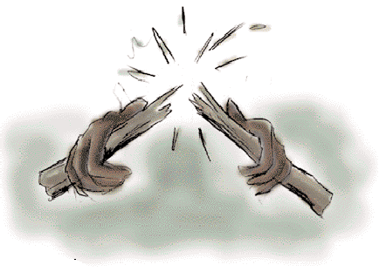

Too often we fail to recognize the difference between the person and the performance. We forget that forgiveness is greater than revenge.

People make mistakes. We are allowed to make mistakes. But the actions we take while in a rage will haunt us forever. Pause and ponder. Think before you act. Be patient. Forgive and forget.

Love one and all.

# THE FATHER AND HIS SONS

A father had a family of sons who were perpetually quarreling among themselves. When he failed to heal their disputes by his exhortations, he determined to give them a practical illustration of the evils of disunion; and for this purpose he one day told them to bring him a bundle of sticks.

When they had done so, he placed the faggot into the hands of each of them in succession, and ordered them to break it in pieces. They tried with all their strength, and were not able to do it. He

next opened the faggot, took the sticks separately, one by one, and again put them into his sons’ hands, upon which they broke them easily.

He then addressed them in these words: “My sons, if you are of one mind, and unite to assist each other, you will be as this faggot, uninjured by all the attempts of your enemies; but if you are divided among yourselves, you will be broken as easily as these sticks.”

**In Union there is strength. Divided we fall; United we stand.**

# A SENSE OF A GOOSE



Next autumn, when you see geese heading south for the winter, flying in a “V” formation, you might consider what science has discovered as to why they fly that way. As each bird flaps its wings, it creates uplift for the bird immediately following. By flying in a “V” formation, the whole flock adds at least 71 percent greater flying range than if each bird flew on its own.

People who share a common direction and sense of community can get where they are going more quickly and easily, because they are traveling on the thrust of one another.

When a goose falls out of formation, it suddenly feels the drag and resistance of trying to go it alone and quickly gets back into formation to take advantage of the lifting power of the bird in front. If we have the

sense of a goose, we will stay in formation with those people who are heading the same way we are.

When the head goose gets tired, it rotates back in the wing and another goose flies point.

It is sensible to take turns doing demanding jobs, whether with people or with geese flying south.

Geese honk from behind to encourage those up front to keep up their speed. What message do we give when we honk from behind?

Finally - and this is important - when a goose gets sick or is wounded by gunshot, and falls out of the formation, two other geese fall out with that goose and follow it down to lend help and protection. They stay with the fallen goose until it is able to fly or until it dies; and only then do they launch out on their own, or with another formation to catch up with their own group.

**If we have the sense of a goose, we will stand by each other like that.**

# MAKING A DIFFERENCE

My friend was walking down a deserted Mexican beach at sunset. As he walked along, he began to see another man in the distance. As he grew nearer, he noticed that the local native kept leaning down, picking something up and throwing it out into the water. Time and again he kept hurling things out into the ocean. As my friend approached even closer, he noticed that the man was picking up starfish that had washed up on the beach, and, one at a time, he was throwing them back into the water. My friend was puzzled.

He approached the man and said. “Good evening, friend. I was wondering what you are doing.”

“I’m throwing these starfish back into the ocean. You see its low tide right now and all of these starfish have been washed up onto the shore. If I don’t throw them back into the sea, they’ll die up here from lack of oxygen.”

“I understand,” my friend replied, “but there must be thousands of starfish on this beach. You can’t possibly get to all of them. There are simply too many. And don’t you realize this is probably happening on hundreds of beaches all up and down this coast. Can’t you see that you can’t possibly make a difference?”

The local native smiled, bent down and picked up yet another starfish, and as he threw it back into the sea, he replied, “Made a difference to that one!”

